REVITALISING AREAS BY PLANNING, INVESTMENT AND DEVELOPMENT (RAPID) PROGRAMME APPLICATION FORM 2017

NOTE: Closing Date 20th November 2017
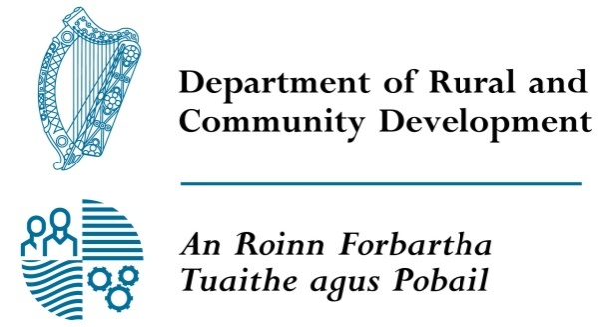
FOR OFFICE USE ONLY

Date Received:

Reference Number:

LCDC recommendation:

Municipal District decision:

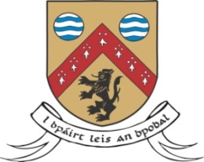
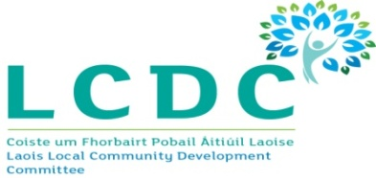

GROUP /ORGANISATION/DEPARTMENT/AGENCY NAME:

ALL APPLICATIONS ARE TO BE RETURNED TO:

Laois Local Community Development Committee
c/o Community Development Section,
Laois County Council,
Áras an Chontae,
Portlaoise,
Co. Laois R32 EHP9

By 5pm on 20th November 2017
CLOSING DATE WILL BE STRICTLY ADHERED TO.

Please read the RAPID Application Guidelines before completing this form.
Please read the Terms and Conditions on page 2.
Please sign DECLARATION on page 6.

Department of Rural and Community Development Revitalising Areas by Planning, Investment and Development (RAPID) Programme

The Department of Rural and Community Development (“the Department”) operates a recast RAPID capital grant programme through the Local Community Development Committees with the over-arching objective being to facilitate a more integrated approach to funding and supports in disadvantaged urban areas/provincial towns. Under the programme, eligible groups/organisations may apply for grants for capital projects or elements of projects which would improve the quality of life for residents in disadvantaged urban areas, providing tangible supports. Applications should relate to at least one key target group and thematic area in order to be eligible for consideration.

Target groups and thematic areas
In line with the ethos of the Programme, applications for funding for projects that target the relevant groups or issues in disadvantaged urban areas which comply with the strategic themes outlined in each Local Economic and Community Plan (LECP) should receive priority.

TERMS AND CONDITIONS

- The Department under the RAPID programme will support a more cohesive and integrated approach to funding and supports in disadvantaged urban areas. The programme does not provide funding for the employment of staff.
- The project must benefit the residents in the disadvantaged area and should relate to at least one key target group and thematic area.
- The information supplied by the applicant group /organisation must be accurate and complete.
- Misinformation may lead to disqualification and/or the repayment of any grant made.
- All information provided in respect of the application for a grant will be held electronically. The Department reserves the right to publish a list of all grants awarded on its website.
- The Freedom of Information Act applies to all records held by the Department and Local Authorities.
- The application must be signed by the Chairperson, Secretary or Treasurer of the organisation making the submission or Principal Officer grade (or equivalent) in the case of a Government Department or State Agency.
- It is the responsibility of each applicant to ensure that it has proper procedures and policies in place including appropriate insurance where relevant.
- Applications must be on the 2017 form.
- Evidence of expenditure, receipts /invoices must be retained and provided to the LCDC or their representative if requested.
- The Department’s contribution must be publicly acknowledged in all materials associated with the purpose of the grant.
- Generally no third party or intermediary applications will be considered.
- Late applications will not be considered.
- Applications by post should use the correct value of postage stamps and allow sufficient time to ensure delivery not later than the closing date of Monday 20th November 2017 at 5pm. Claims that any application form has been lost or delayed in the post will not be considered, unless applicants have a Post Office Certificate of Posting in support of such claims.
- Breaches of the terms and conditions of the grants programme may result in sanctions including disbarment from future grant applications.

All questions on this form must be answered. Please write your answers clearly in block letters.

SECTION 1 – CONTACT DETAILS
Name of Group / Organisation / Government Department / State Agency

Address

Eircode

Contact name

Role in applicant organisation

Telephone number
E-mail

Website

Have you received funding under any capital grants scheme or programme within the last three years? YES/NO (delete as appropriate)

If YES please give details:-
Name of scheme/programme | Funding organisation | Amount of funding

If any of the above funding was paid through the Local Authority, have you submitted your Bank Account Details previously?
YES/NO (delete as appropriate)

Please give details of your group /organisation which appear on the Bank Account
Group / Organisation name
Address
Contact name
Email address

SECTION 2 - GROUP/ ORGANISATION DETAILS

Purpose of group / organisation

Year established

Please provide a brief organisational description of your group / organisation e.g. committee structure, meeting schedule etc.

Has your Organisation / Group registered with the relevant local Public Participation Network (PPN)?
YES/NO (delete as appropriate)
If NO, then perhaps you would consider joining the PPN.

Do you receive funding from any other organisation?
YES/NO (delete as appropriate)

If YES please give details below:

Funding organisation | Amount received | Date received

Is your organisation affiliated or connected to any relevant local regional or national body? YES/NO (delete as appropriate)

If YES please give details below:
Name of organisation(s):

How does your organisation link in with other organisations in your area?

Charitable Status Number (if applicable):

Tax Reference Number (if applicable):

Tax Clearance Access Number (if applicable):

SECTION 3 - PURPOSE OF GRANT AND FUNDING

PURPOSE

Please insert the relevant target groups or issues that comply with the strategic theme(s) from the Local Economic and Community Plan, which this grant application relates to:

Relevant target groups or issues | Strategic theme identified in the LECP | Approximate number of people who will benefit

What is the purpose of the grant? (Outline details of the project).

FUNDING

Amount being applied for under RAPID: | €
Is this amount partial or total project cost: | ☐Partial | ☐Total
If partial, give estimated total project cost: | €

Where will you source any shortfall of funding?

Source | Amount

SECTION 4 - DECLARATION

Position held in organisation: ________________________________

I declare that the information given in this form is correct.

I confirm I have read and fully understand the Terms and Conditions of the RAPID Programme (see page 2 of application form).

I confirm that I have read the RAPID Application Guidelines prior to completing this form.

I confirm that this grant application is submitted in acceptance of and compliance with the Terms and Conditions.

I confirm that the applicant group/organisation does not have the funding to undertake the work/project without this grant aid or alternatively that with the grant the applicant group/organisation will now undertake a larger project which they otherwise would not be able to afford.

I confirm that the applicant group/organisation is tax compliant (if tax registered).

Name in block capitals (on behalf of group / organisation):

Signature:

Position held in group / organisation (block capitals):
Date:

