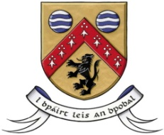

Laois County Council

In partnership with

Laois Public Participation Network

Community & Voluntary Awards 2018
Nomination Form

Unsung Hero

This form should be used to nominate an individual in recognition of
their significant contribution to Community & Voluntary life in Laois

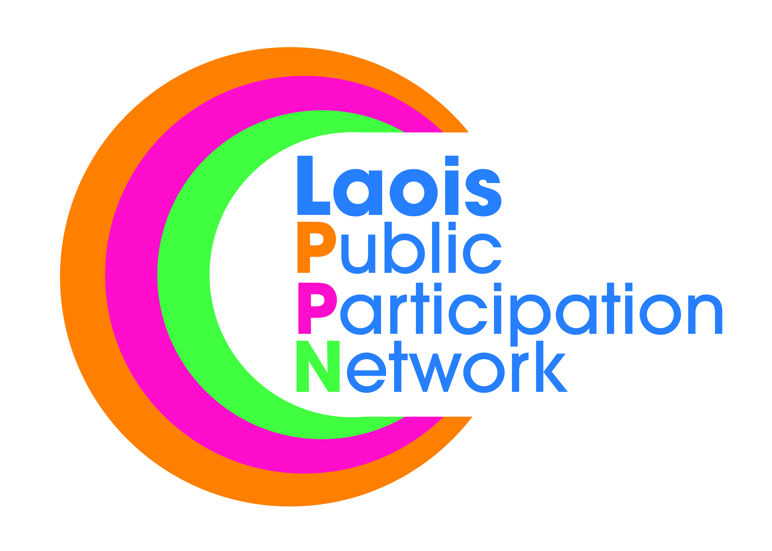

N.B! Before completing this form, please read the accompanying terms & conditions and judging criteria
Application Form
I wish to nominate the following person for an Unsung Hero Award:
Name of the person being nominated
Address
Phone No. (daytime contact)  Mobile number | 
Email address for contact | 
Details of person or Group making the nomination:
Your Name (individual/group)
Your Address
Phone No. (daytime contact)
Mobile Number
Email address for contact | 

Is the person you have nominated, a member of a community/voluntary group/organisation in Laois?
Yes No Don’t know
If yes, please name the group/organisation

Please outline the reasons why you/your group wish to nominate this person for an Unsung Hero Award:
_______________________________________________________________________________________________________________________________________________________________________________________________________________________________________________________________________________________________________________________________________________________________________________________________________________________________________________________________________________________________________________________________________________________________________________________________________________________________________________________________________________________________________________________________________________________
______________________________________________________________________________________________________________________________________________________________________________________________________________________________________________________________________________

Please highlight your nominee’s current/recent contribution to their local community:
_______________________________________________________________________________________________________________________________________________________________________________________________________________________________________________________________________________________________________________________________________________________________________________________________________________________________________________________________________________________________________________________________________________________________________________________________________________________________________________________________________________________________________________________________________________________________________________________________________________________________________________________________________________________________________________________________________________________________________________________________________________________________________________________________________________________________________________________________

How do you think your nominee has made a positive impact on the community?
*you can use a separate sheet to set this out if necessary
_____________________________________________________________________________________________________________________________________________________________________________________________________________________________________________________________________________________________________________________________________________________________________________________________________________________________________________________________________________________________________________________________________________________________________________________________________________________________________________________________________________________________________________________________________________________________________________________________________________________________________________________________________________________________________________________________________________________________________________________________________________________________________

TERMS & CONDITIONS:
Unsung Hero Award
Nominations should be made by a group/individual for a particular individual to receive a special award, in recognition of this individual’s significant contribution to Community and/or Voluntary life in our county and beyond, if appropriate.

Completed application should be marked
“Community & Voluntary Award 2018 Nomination”
and sent by:

New Extended Date Friday 7th September, 2018 @ 5pm

To:

Ms. Pamela Tynan
Community Development Section
Laois County Council
County Hall, Portlaoise
Co Laois
For further assistance and queries, please contact: 057 86 64150
or e-mail: dce@laoiscoco.ie

