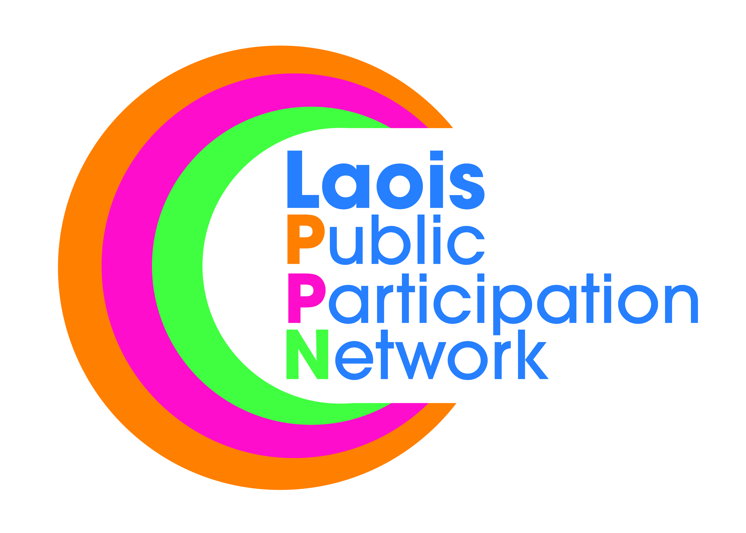
Laois Public Participation Network
Meeting of PPN Secretariat
Monday, 8th October at 8.00pm
PPN Office, JFL Avenue, Lyster Square, Portlaoise

AGENDA

8.00 PM
- Review Age Friendly Information Afternoon / Plenary
- National Conference
- Training – Sinead Doody
- Training Workshops for Member Organisations
- Disability Workshop
- AOB

List of Project for Laois PPN
- Bye-laws to ban posters in towns in Laois.
- Carbon Monoxide Alarms
- Renovation of Community Centres
- Training
- Parking of vehicles on footpaths – Raise awareness
- Refundable tariff on drink cans and plastic bottles

