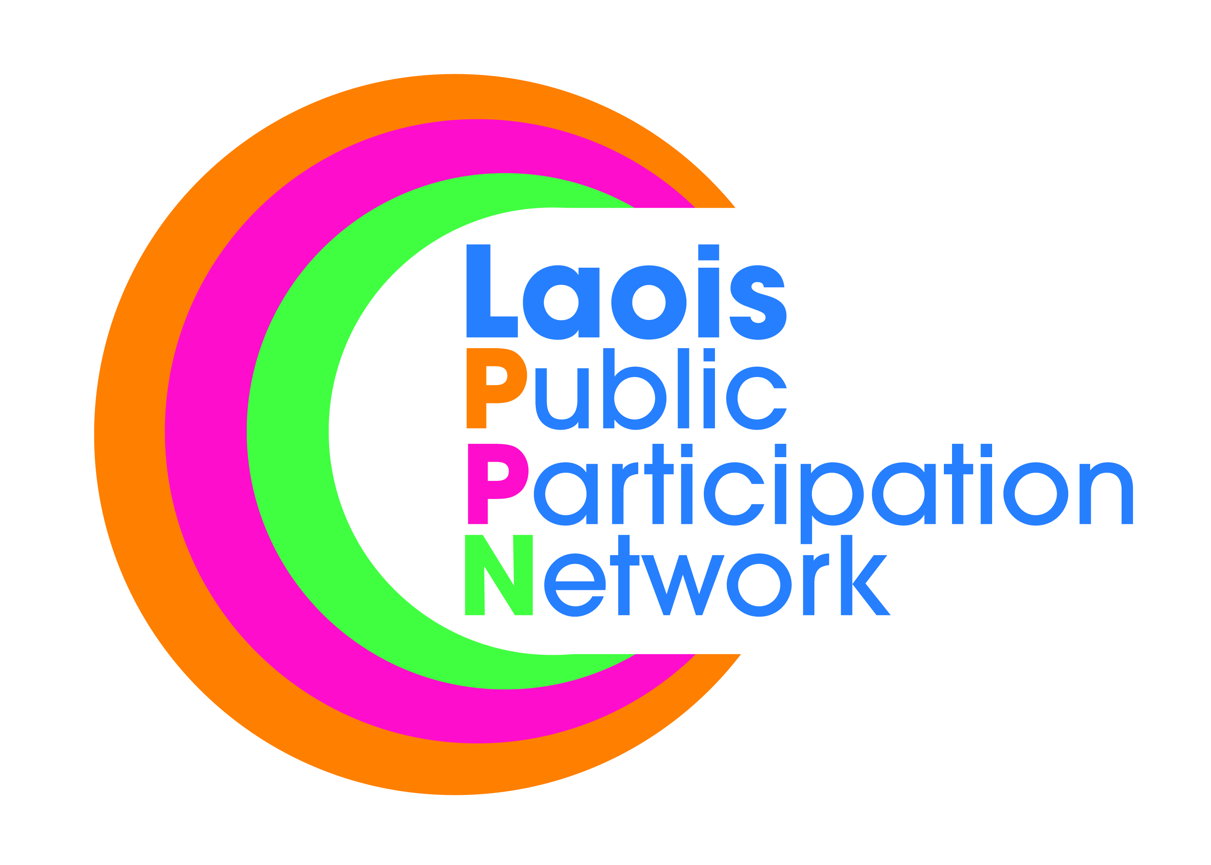
Laois Public Participation Network
Meeting of PPN Secretariat
Monday, 12th November at 8.00pm
PPN Office, JFL Avenue, Lyster Square, Portlaoise

AGENDA

- PM
- Minutes of Meeting 8th, Oct 2018.
- Review National Conference
- Training – Sinead Doody (scheduled Sat 24th Nov 2018)
- Disability Workshop
- Irish Environmental Network – Sustainable Goals
- PPN to be acknowledged when funds allocated
- AOB
- Set Date for next monthly meeting and elect chair for next three meetings.

List of Project for Laois PPN
- Bye-laws to ban posters in towns in Laois.
- Carbon Monoxide Alarms
- Renovation of Community Centres
- Training
- Parking of vehicles on footpaths – Raise awareness
- Refundable tariff on drink cans and plastic bottles

