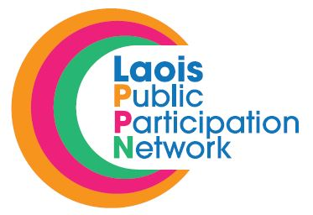 28th November 2018.

RE: Laois Public Participation Network (PPN) – Nominations to Secretariat (Community/Voluntary)
Graiguecullen/Portarlington

A Chara,

I refer to the above and wish to advise that Laois PPN are inviting registered groups within the Community/Voluntary Pillar in the Graiguecullen/Portarlington MD to fill the vacant seat on the Secretariat of the Laois PPN.

It is important that the position is filled to ensure that the Community/Voluntary Pillar has a strong and equal voice on the Secretariat.

If a member of your group is interested in being nominated to run for election for the above position, please have them complete the attached nomination form and return in the pre-paid envolope.

Deadline for receipt of nominations is 4.00pm on Friday, 14th December, 2018

If more than one nomination is received for a position voting will take place at a meeting of the Environment Pillar. You will be notified in due course in relation to same.

Should you have any queries, please contact me on 057-8665661 or email soconnor@laoiscoco.ie

Is mise le meas,

Suzanne O’Connor

Suzanne O’Connor,
Acting Laois PPN Coordinator,
Laois Public Participation Network.

