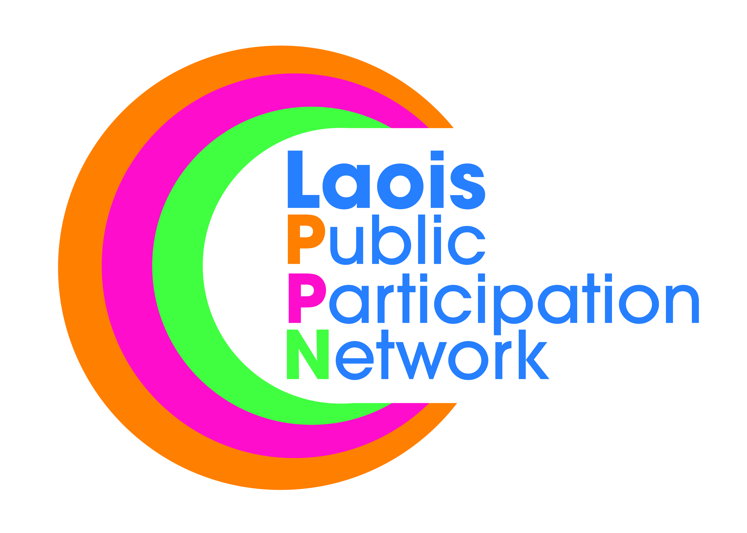
Laois Public Participation Network
Minutes of Meeting of PPN Secretariat
Monday, 8th October, 2018, at 8:00pm
PPN Office, Lyster Square, Portlaoise, Co Laois

Present: Mr. Eugene O’Brien (Chair)
Mr. Donal O’Shea
Mr. Mick Dowling Snr
Mr. Paddy Buggy
Mr. Brian Maher
Mr. Robbie Quinn

Apologies: PJ Campbell
Michael Cobbe

In Attendance: Ms. Suzanne O’Connor, A/PPN Coordinator.

The minutes of the meeting held on 10th September, 2018 were proposed by Paddy Buggy, seconded by Mick Dowling Snr, confirmed and signed.

- Plenary: Platform to engage with council/elected members. While attendance on the night was disappointing guest speaker Mr. John Lonergan was very impressive, funny which lead to a very relaxed atmosphere.

- It was suggested that a PPN promotional video should be made as currently we have no profile. Talk to other PPN’s and contact the Dept in relation to this.

- Re-registration – Mick Dowling Snr made a very good suggestion that re-registration should take place after the New Year, when all the clubs AGM’s are completed as this will result in the changing of contacts within organisation.

- Money given out through LCDC was just the case of sign a form, no commitment for active involvement with Laois PPN.

- In regards to meetings/events it’s hard to get some people out at night. Each member organisation should delegate for a member to attend. It was noted that if something doesn’t affect you directly, people won’t attend.

- Provisions need to be put in place for a succession plan.

- “Over 50’s Information Afternoon”. 110 signed in on the day, but estimated that 130 attended the event. Need to re-think the registration process.

- National Conference: Those who attended to provide update.

- Doody Training: Agreed that next training should take place on Saturday 24th Nov with all Secretariat Members and Reaps invite. Secretariat and Reps should meet before training commenced with each rep asked to provide a report from relevant committees. Training to focus on getting Linkage Groups up and running. Breakfast to be provided.

Meetings of sec/reps 9:00am-10:00am.
Breakfast 10:00am
Training 10:30am – 1:00pm

- Contact committees re schedule of meetings
- What are the PPN trying to achieve?
- Get items on the agenda.
- Misunderstanding between reps.
- Transparency.

- Need plan/strategy before meeting with CE John Mulholland and Donal Brennan.

- Disability Workshop: It was agreed to progress with the workshop and find out price and availability of Paul O’Raw who has done the same workshop for Kerry PPN.

AOB:

- Suzanne informed secretariat in relation to Laois Co Co weather alert. A good debate took place and it was agreed that Laois PPN will send out alerts on behalf of Laois Co Co, but will not facilitate the sharing of information. Laois PPN must be seen as independent. A comment was made that Laois Library should be asked as they hold a much larger database.
- Laois CNN – good to engage with the youth. Deemed as a good idea.
- It was agreed to send out information from the environmental network re sustainable goals.

This concluded the business of the meeting.

Signed:
Chairperson

Date: / /

