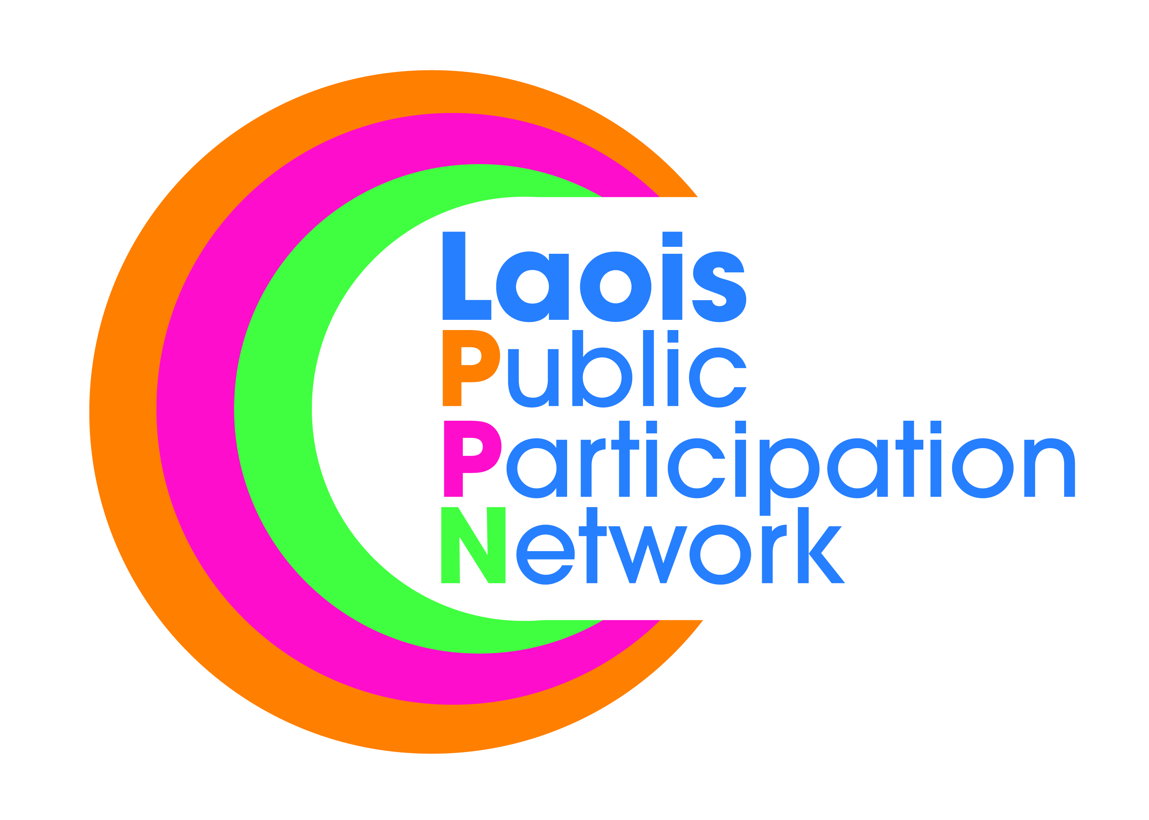
Nomination Paper for Laois Public Participation Network
Community/Voluntary Representative (to PPN Secretariat)
Graiguecullen/Portarlington MD
To the Returning Officer:
- I nominate the person named under as a candidate for election to the above-mentioned committee as the Community/Voluntary representative.
- I confirm upon signature that I have read and understood the notes (overleaf*) on this nomination paper and declare that I believe this person to be eligible for this position.
Please use BLOCK LETTERS
Surname of Candidate Other Names

Address Occupation (if any)

Signature of Candidate

Name of Nominating Group/Organisation PPN Ref. No.

Name of Person completing this Nomination Form (Proposer)
Please Print Signature
Please attach passport size photograph of candidate for inclusion on ballot paper
Date
Address of Proposer

Daytime Tel. No

NOTES:
- The completion of this form nominates a candidate to stand election for:
Community/Voluntary representative to the PPN Secretariat for the Graiguecullen/Portarlington MD.
- The PPN Secretariat will be the hub of the PPN Structure and the mechanism through which all operations will take place. 12 community representatives will be responsible for the operation of the PPN, i.e., convening plenary meetings at county and municipal district levels, providing networking opportunities between local and/or like minded groupings and ensuring that a two-way feedback process is maintained between community groups and the local authority.
- The person to be nominated must be a member of a group/organisation that is registered with Laois Public Participation Network.
- The group making the nomination must be registered with Laois Public Participation Network

- The group nominating MUST be a member of the pillar grouping, i.e., to be nominated as a Community/Voluntary rep, it must be a Community/Voluntary group nominating you (similarly for Environmental and Social Inclusion reps).
- Clearly mark the envelope “Secretariat Nomination – Community/Voluntary” and return in the Pre Paid envelope provided.

- A receipt for your nomination will be issued to the nominee and a valid declaration will issue subsequently, if applicable.
- Deadline for receipt of nominations is 4.00pm, Friday, 14th December 2018.

