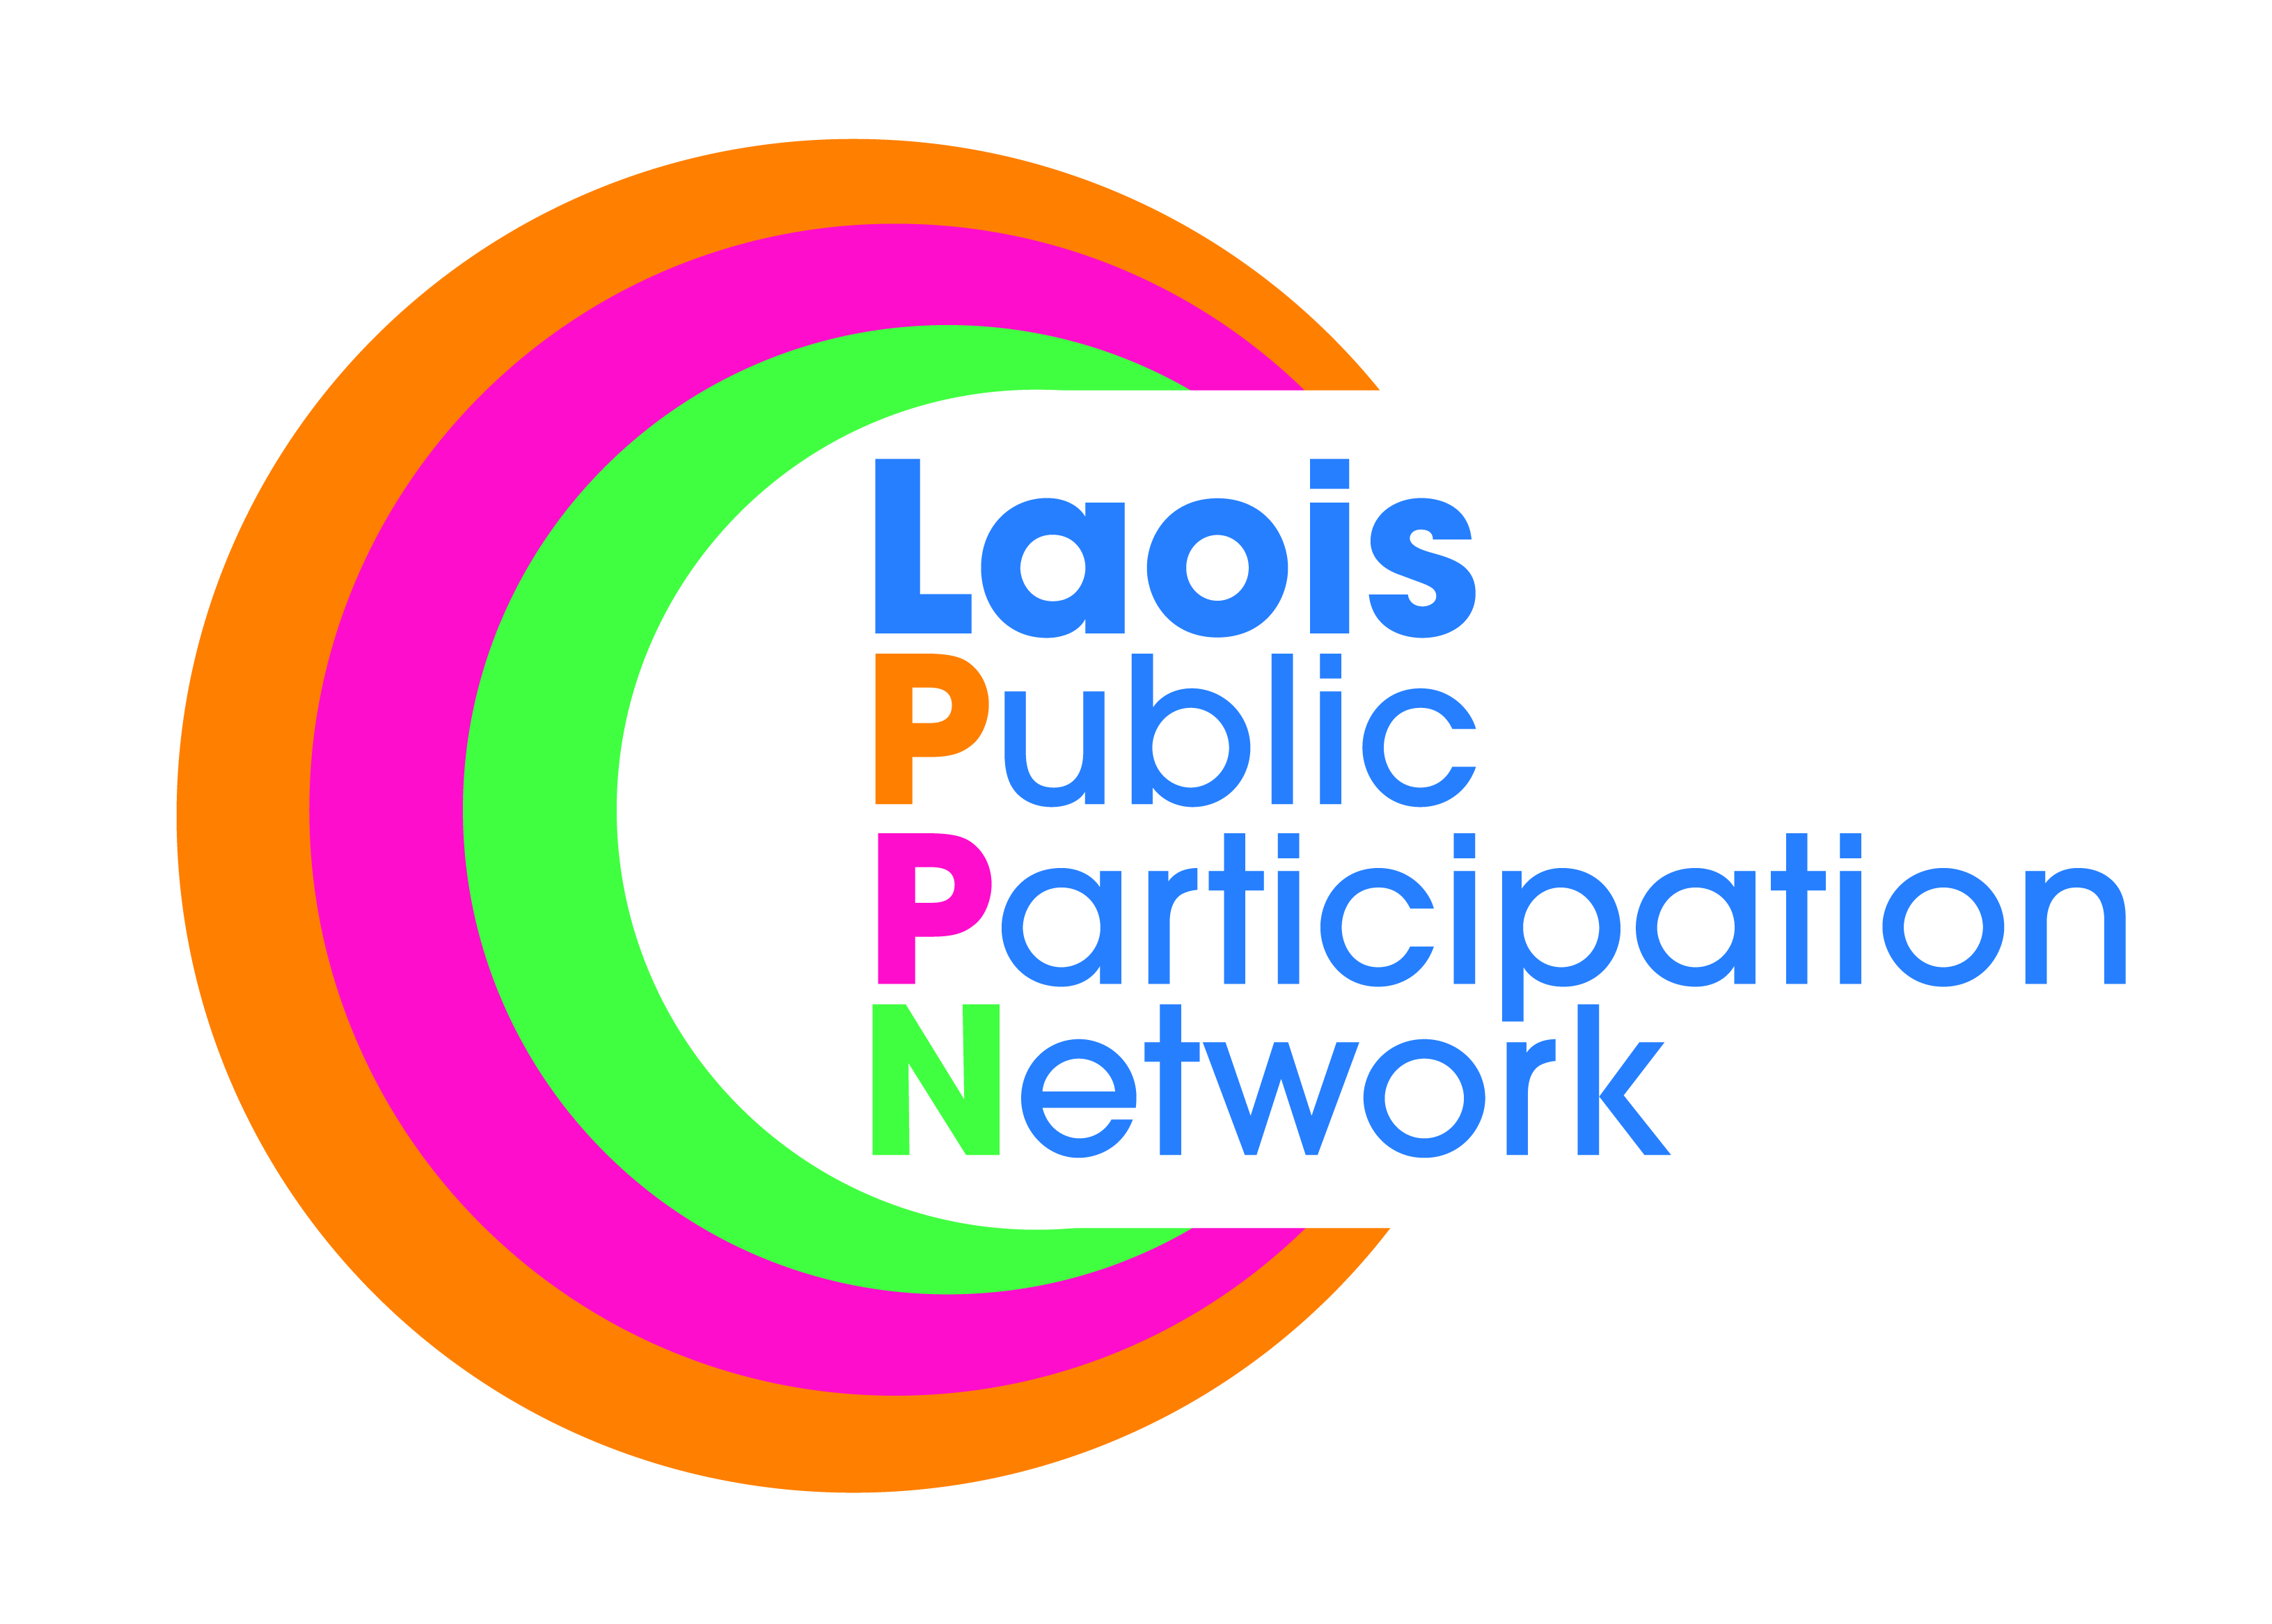
Nomination Paper for Laois Public Participation Network
Environmental Representative
(to Local Community and Development Committee - LCDC)
ALL MUNICIPAL DISTRICTS
To the Returning Officer:
- I nominate the person named under as a candidate for election to the above-mentioned committee as the Environmental representative for the Local Community and Development Committee (LDCD).
- I confirm upon signature that I have read and understood the notes (overleaf*) on this nomination paper and declare that I believe this person to be eligible for this position.
Please use BLOCK LETTERS
Surname of Candidate Other Names

Address Occupation (if any)

Signature of Candidate

Name of Nominating Group/Organisation PPN Ref. No.

Name of Person completing this Nomination Form (Proposer)
Please Print Signature
Please attach passport size photograph of candidate for inclusion on ballot paper
Date
Address of Proposer

Daytime Tel. No

NOTES:
- The completion of this form nominates a candidate to stand election for:
Environmental representative in the Local Community and Development Committee (LDCD)

- LCDCs key function is to achieve a more strategic, joined up approach to local and community development. LCDCs will have oversight and responsibility for local development and community related funding in their county. The LCDC is responsible for the rollout and monitoring of delivery of social inclusion programme Social Inclusion Community Activation Programme 2018—2022 (SICAP).. Each LCDC will develop a six year Economic and Community Plan (LECP). This plan will agree the strategic framework for economic and community development for the county. It will inform community and local development resource allocation, and inform other planning processes. The community element of the plan will be prepared by the LCDC, with the economic element prepared by the SPC for Economic Development and Enterprise Support. There is a requirement that both elements are prepared concurrently and form the basis for one overall LECP. This plan will be presented for approval by Council in early 2015.
- The person to be nominated must be a member of a group/organisation that is registered with Laois Public Participation Network.
- The group making the nomination must be registered with Laois Public Participation Network.

- The group nominating MUST be a member of the respective pillar grouping, i.e., to be nominated as a Environmental rep, it must be an Environmental group nominating you (similarly for Community and Social Inclusionl reps).
- Clearly mark the e-mail “PPN ELECTION NOMINATION”.

- A receipt for your nomination will be issued to the nominee and a valid declaration will issue subsequently, if applicable.
- Deadline for receipt of nominations is 4.00pm, Friday, 14^{h} Dec 2018.

