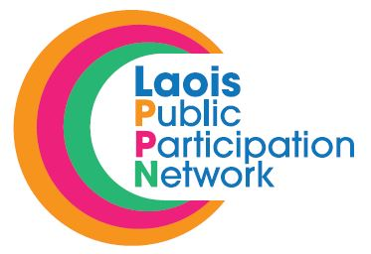 28th November 2018.

RE: Laois Public Participation Network (PPN) – Nominations to Committee

A Chara,

Laois PPN are now inviting nominations from registered groups in the Environmental Pillar for representation on the following:

Local Community and Development Committee (LCDC)

If a member of your group is interested in being nominated to run for election for the above committee, please have them complete the attached nomination form and return to soconnor@laoiscoco.ie

Deadline for receipt of nominations is 4.00pm on Friday, 14t^{h} December, 2018.

Voting will take place by postal vote when nominees have been confirmed.

Should you have any queries, please contact me on Tel. 057 – 8665661 / 086 – 7782551 or email soconnor@laoiscoco.ie

Is mise le meas,

Suzanne O’Connor,
A/Laois PPN Coordinator,
Laois Public Participation Network.

