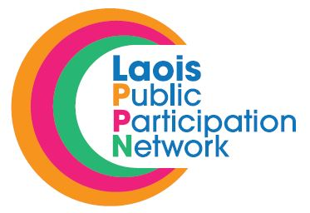 28th November 2018.

RE: Laois Public Participation Network (PPN) – Nominations to Secretariat (Environmental Pillar)
Borris-in-Ossary/ Mountmellick

A Chara,

I refer to the above and wish to advise that Laois PPN are inviting registered groups within the Environment Pillar in the Borris-in-Ossary/Mountmellick MD to fill the vacant seat on the Secretariat of the Laois PPN.

It is important that the position is filled to ensure that the Environment Pillar has a strong and equal voice on the Secretariat.

If a member of your group is interested in being nominated to run for election for the above position, please have them complete the attached nomination form and return to Ms. Suzanne O’Connor, Acting PPN Coordinator, Laois Public Participation Network, JFL Avenue, Lyster Square, Portlaoise, Co. Laois.

Deadline for receipt of nominations is 4.00pm on Friday, 14th December, 2018

If more than one nomination is received for a position voting will take place at a meeting of the Environment Pillar. You will be notified in due course in relation to same.

Should you have any queries, please contact me on 057-8665661 or email soconnor@laoiscoco.ie

Is mise le meas,

Suzanne O’Connor

Suzanne O’Connor,
Acting Laois PPN Coordinator,
Laois Public Participation Network.

