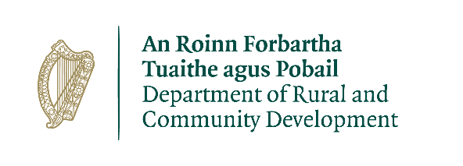

CLÁR 2019 Scheme Outline

Measure 2

Background
CLÁR (Ceantair Laga Árd-Riachtanais) is a targeted investment programme for rural areas that aims to provide funding for small infrastructural projects in areas that experience disadvantage. The aim of CLÁR is to support the sustainable development of identified CLÁR areas with the aim of attracting people to live and work there. The funding works in conjunction with local/Agency and other Departmental funding programmes and on the basis of locally identified priorities.

Funding Allocation for 2019
There is an allocation of €5 million in total for 2019 under 3 Measures:
CLÁR 2019 will provide funding under the following measures:
Measure 1: Support for Schools/Community Safety Measure (per 2018)
Measure 2: Play Areas (including MUGAs) (per 2018) and
Measure 3: Community Wellbeing Support (new in 2019) comprising of
(a) First Response Support,
(b) Mobility and Cancer Care Transport, and
(c) Sensory Gardens.

In 2019, Local Authorities may make applications for funding under Measures 1, 2 and 3(c).

Timelines

Scheme launch | 28 February 2019
Applications to be received by the Department | By 25 April 2019
Assessment and decisions, contracts | By 28 June 2019
Project and drawdown completed | By 31 October 2019

Applications
The 2019 programme will again allow for applications to be submitted to the LA from Schools, Community Groups and also from Local Development Companies.

Up to 15 applications in total, between Measures 1 and 2, may be selected by the LA, providing that they are of sufficient quality, in line with the scheme outline, and are consistent with developmental planning at a local level, LECP’s, town plans and any other relevant plans, for onward submission to the Department for its consideration.

Assessment Criteria
In assessing applications for recommendation to the Minister, a number of factors will be considered including the indicated order of priority; the range, mix, quality and impact of proposed projects; previous funding provided; and other relevant considerations.

Eligible Costs
Applications should detail all of the costs associated with the proposed project and only items of a capital nature that are integral to the project should be included.

All administration costs/professional fees associated with the proposed project should be kept to a minimum and be clearly detailed on the Application Overview. Such costs will be eligible up to a maximum of 10% of the overall project costs.

Grant Payment arrangements
100% after certification by the LA/LDC that the project has been completed.

Drawdown requests for payment should only be submitted by the LA/LDC when the LA/LDC has itself incurred the expense. It is not acceptable that a drawdown request be submitted to the Department if invoices etc. submitted to the LA/LDC by community groups/contractors remain unpaid.

Detailed Measure Outline

Measure 2: Schools/Community Play Areas (including MUGAs)
CLÁR 2019 will consider support for the enhancement of existing and/or the development of new School/Community Play areas.

Eligible Applicants: Schools, Community Groups, Local Development Companies, Local Authorities.

The measure will be implemented via the LA’s. Projects proposed to the Department by the LA’s must be selected on the basis of:
- an application by a School/Community/LDC to the LA
- evidence that all necessary permissions are in place
- evidence, where applicable, that ownership/lease is in place
- full estimated costs including administration/professional fees (procurement not required at this point)
- evidence that match funding is in place where relevant
- being open to the public without appointment
- clear evidence of need, and
- relevance to the LECP/other plan.

Rate of Aid
A minimum grant of €5,000 and a maximum grant of €50,000 for projects will be available. The maximum grant payable will be 90% of the project cost or a maximum of €50,000, whichever is the lesser. The remaining 10% or balance of the cost should be provided through local authority/community/other resources with a minimum of 5% cash contribution from the School/Community.

