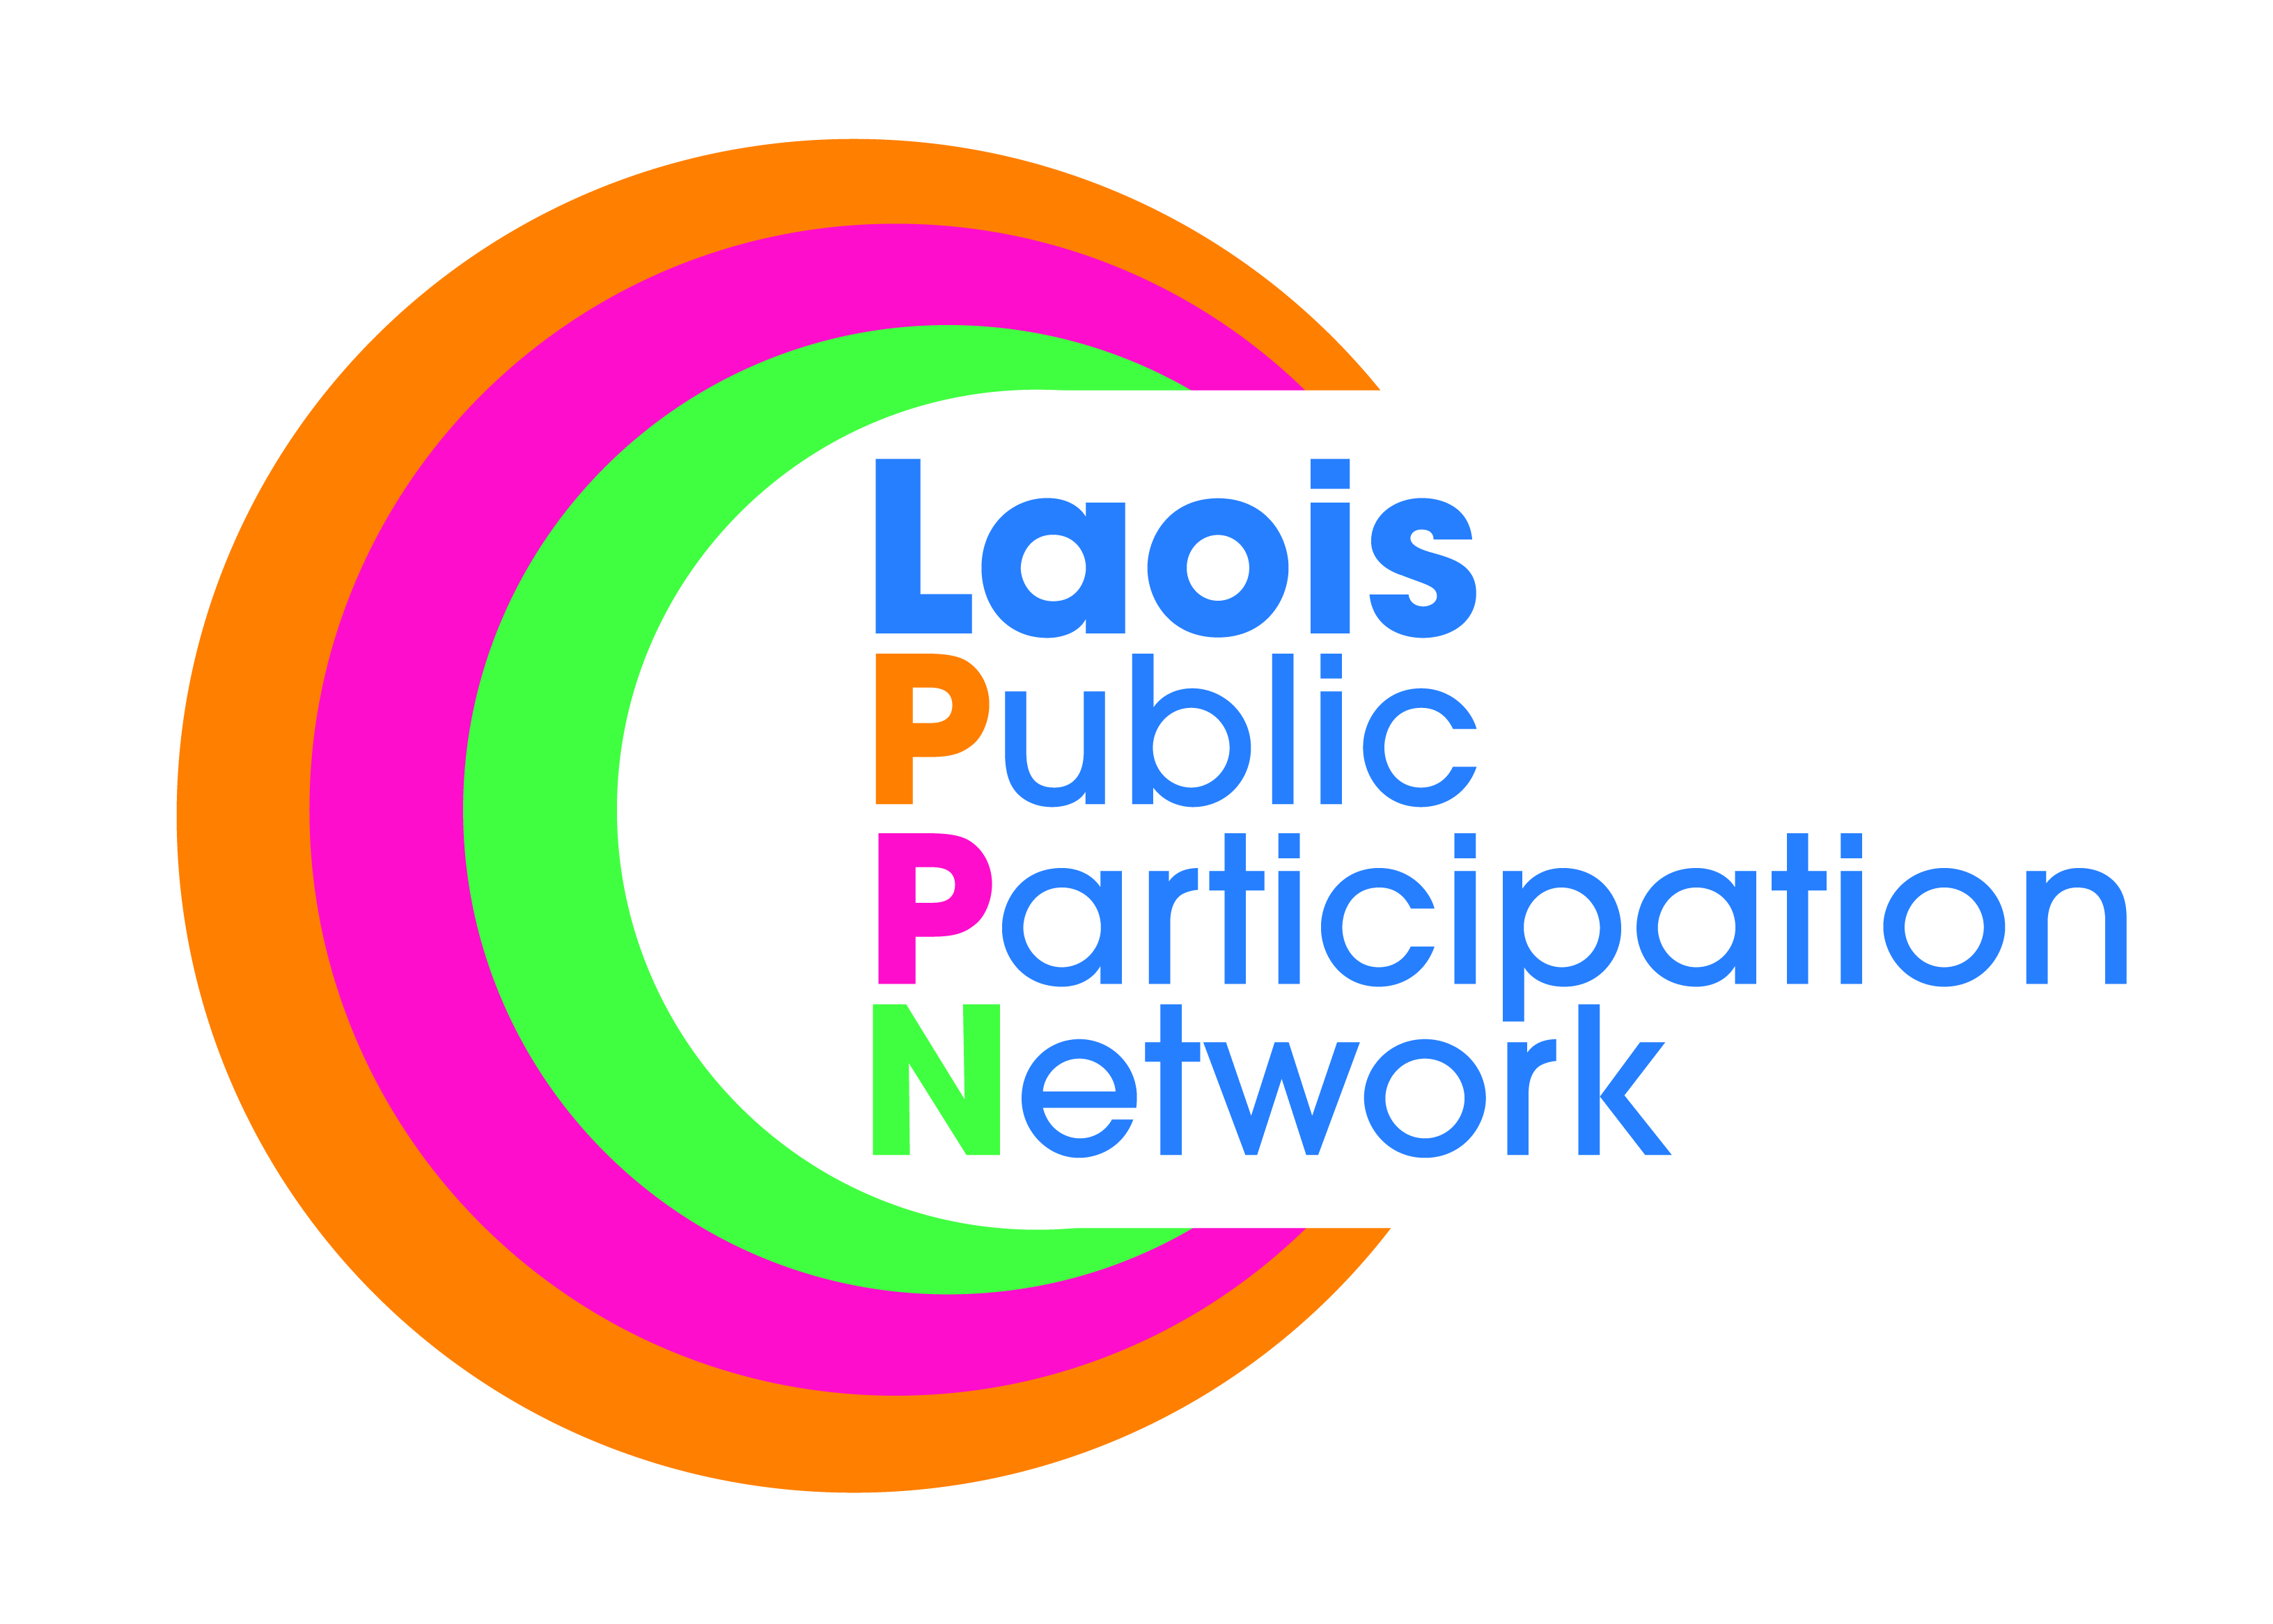
Laois Public Participation Network
Minutes of Meeting of PPN Secretariat
Monday, 16th January 2019, at 8:00pm
Laois PPN Office, Lyster Square, Portlaoise, Co. Laois

Present: Mr Robbie Quinn
Mr. PJ Campbell

Apologies: Mr. Donal O’Shea
Mr. Paddy Buggy
Mr. Bolaji Adeyanju

In Attendance: Ms. Suzanne O’Connor, A/PPN Coordinator.

The minutes of the meeting held on 13th December, 2018 were proposed, seconded, confirmed and signed.

- Due to late notice of unavailability of secretariat members there no quorum to uphold the meeting. As a result a brief discussion between those present took place.

- “Access for All” – Disability/Community Awareness Workshop. At present we have 27 places booked for our upcoming event with 16 note takers/facilitators required for the 8 tables (2 per table). We therefore need another 37 people to register for the event. It was suggested that we should e-mail all schools asking them to distribute the information. Meeting with Jim O’Brien/Storm Powell is scheduled for Tuesday 22nd Jan @ 7:30pm.

- Further to a meeting with PJ Cleere, Disability Federation of Ireland, it was suggested that funding could be sourced to run a “Train the trainer” programme.

- Carbon Monoxide Alarms – Still awaiting clarification from the Dept.

- PPN Plenary - Funding and Resource Workshop, based on the success of last year’s event. Also ask groups their top 10 lists of projects for Laois PPN and ask them to vote on same. This will then form the List of Projects to appear on the agenda of Laois PPN.

- SafeTalk – Laois PPN to run their own individual event and advertise through eventbrite and usual methods of newsletter, e-mail and social media. Min 12, Max 24 participants.

- National PPN Secretariat – Still no update for NAG/Dept.

This concluded the business of the meeting.

Signed:
Chairperson

Date: / /

