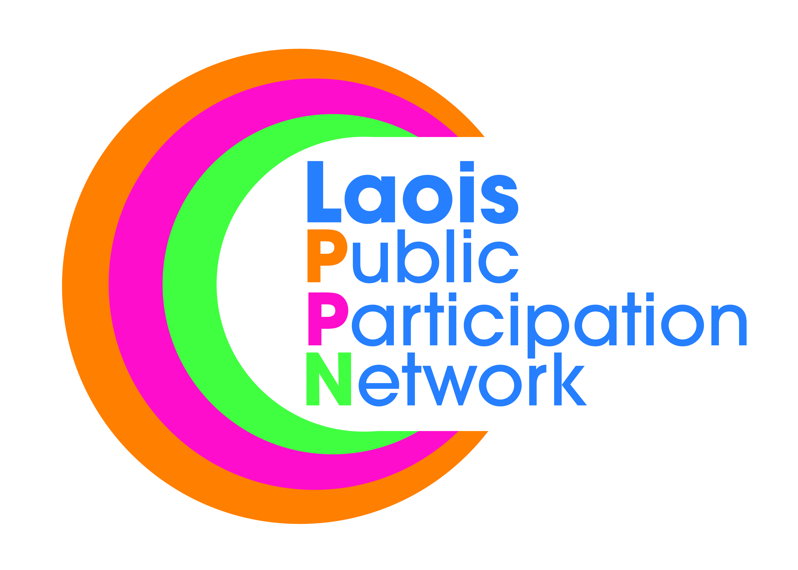
Laois Public Participation Network
Minutes of Meeting of PPN Secretariat
Monday, 18th February 2019, at 8:00pm
Laois PPN Office, Lyster Square, Portlaoise, Co. Laois

Present: Mr. Mick Dowling
Mr. PJ Campbell
Mr. Michael Cobbe – Chair
Mr. Paddy Buggy
Mr. Donal O’Shea

Apologies: Mr. Robbie Quinn
Mr. Brian Maher
Mr. Bolaji Adeyanju

In Attendance: Ms. Suzanne O’Connor, A/PPN Coordinator.

The minutes of the meeting held on 16th January, 2019 were proposed by PJ Campbell, seconded by Suzanne O’Connor, confirmed and signed.

- The “Access for All” Disability Community Awareness Workshop had a great attendance with over 80 people present on the night. It was proposed that a person with a disability should be on the Secretariat and each SPC of Laois Co Co. It was noted that not all disabilities are visible. There should be a call for organisation representing those with disabilities to register with Laois PPN. Overall it was a very successful night. As a result a forum should be established.

- Support Worker. It was unanimously agreed that the new role of support worker should be recruited from the existing Clerical Officer Panel (Grade III) within Laois Co Co. This would prove to be more time and cost effective.

- National Conference. It was decided that Laois PPN would refrain from expressing an interest in hosting the PPN National Conference in 2019. Budget would be an issue as it was noted that there could be an overrun. We can look at this again for the 2020 conference.

- Midlands Regional PPN: The secretariat expressed that they would prefer to put more effort into the Midlands Region PPN. The next meeting is scheduled for May 15th with Laois agreeing to be the host county. Paddy Buggy has agreed to chair the meeting in line with the agenda and time allocations. It was discussed should the Midlands Region PPN make representation on behalf of all 5 member counties (Laois, Offaly, Kildare, Meath and Westmeath). It was decided that all counties should make their own submission along with a Midlands Region PPN submission which is signed by all counties. Need momentum to be taken seriously.

- Funding & Resources Workshop will take place on Monday 25th March in the Midlands Park Hotel from 5:00pm – 9:00pm. The secretariat agreed that there should be no speaker on the night as in the previous event they could not be heard. Laois PPN will undertake a funding road show with guest speaker throughout the three municipal districts.

- Paddy Buggy proposed the Mick Dowling should chair the next three meetings; this was seconded by Michael Cobbe.

- Community and Voluntary Awards 2019. This will be the 10th anniversary of the awards and this year we want to make the event bigger and better. Laois PPN agreed to increase the budget from €3000 to €6000 for 2019 event only. The budget will revert to €3000 for the 2020 awards. All members of the secretariat to be invited to attend.

- Re-Registration will begin in the coming weeks. Laois PPN will notify all member organisation who do not have an e-mail address to update their contacts and then re-registration will begin.

- Well Being Statement. The Dept have issued a directive that each PPN must compile a municipal district and county well being statement. This work will commence after training has been delivered by Social Justice Ireland.

- List of projects. The removal of Bye-Laws to ban posters in town in Laois was agreed as Laois PPN progressed this topic which was rejected by the elected members. It was agreed that we would ask member organisation to inform Laois PPN of the top 5 issues they face within their communities.

- Aidan Mulally resigned his seat as the environment rep for Graiguecullen/Portarlington Municial District. Laois PPN now have no environmental Rep on the secretariat. Laois PPN to make contact with the Irish Environmental along with member of the Midlands Regional PPN to seek that Tidy Towns groups can be affiliated with the environmental sector.

This concluded the business of the meeting.

Signed:
Chairperson

Date: / /

