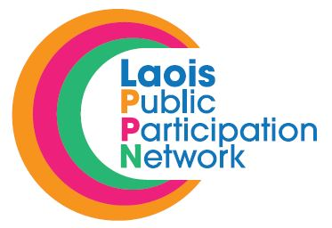
Midlands ISL Learners Beginners ISL Course Application

Name of Group: ______________________________
Address: ______________________________
______________________________
PPN Number: ______________________________

Please only supply details of a nominated person if you have permission to do so. Please tick the box below to confirm that you have their permission to supply their contact details.
Nominated Person Permission:

Nominated Person: ______________________________
Address: ______________________________
______________________________
Phone Number: ______________________________
E-mail Address: ______________________________

Role within your Group: ______________________________

Q1: Brief history of what your organisation/group does, how many people are involved.

Q2: How would this course benefit your group/organisation?

Please return completed application form for the attention of:
Laois Public Participation Network. Lyster Square, Portlaoise, Co. Laois,
or email: ppn@laoiscoco.ie
In making this application I agree to the following:
- This form will be treated as incomplete without the form being completed in fill.
- Only groups/organisations registered with Laois PPN will be considered.
- Only one application per group/organisation.
- Laois PPN will review all application and reserve the right to allocate course space to suitable applicants.
- Applicants will be notified of decision via e-mail.
- Closing Date for Receipt of Application: WEDNESDAY 17th APRIL 2019 @ 4:00pm.
Signed: _________________________ Date:_________________________

