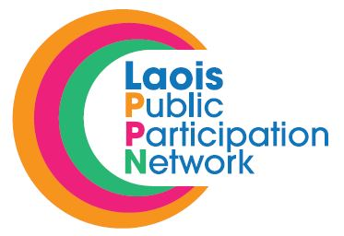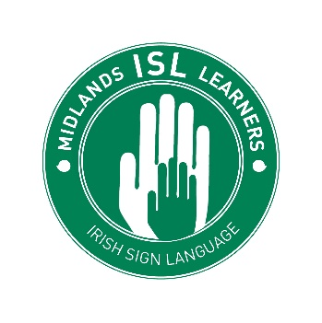
Midlands ISL Learners Beginners ISL Course Structure
Course Overview
Midlands ISL Learners offers a course in Basic Irish Sign Language.
This course is suited to complete beginners and to those with no previous knowledge of Irish Sign Language.
Irish Sign Language (ISL) is the sign language used in Ireland.
This course gives a concise overview of ISL, basic signs and instructions.
It will also teach some basic strategies those with hearing can use when communicating with Deaf of Hard of Hearing people in a respectful and effective way Students will also gain an understanding of the problems and barriers that people who have a hearing loss can often experience.

Qualifications Gained
- Certificate of Attendance in Beginners Irish Sign Language from Midlands ISL Learners

Entry Requirements
- There are no previous academic requirements for this course.

Course Structure
- The course is 5 weeks in duration. One 60 min class per week.

Course Delivery
- Classroom based

Course Content
- Background to Irish Sign Language in Ireland
- Communication Strategies and Body Positioning
- ISL Alphabet and Finger Spelling
- Basic Communication –Numbers/ Family/Colours/Adverbs & Adjectives/Animals
- Interacting with a Deaf Person
- ISL in Practice

Course Fee
- This course will be offered FREE of charge to 10 individuals from 10 different PPN member groups.

