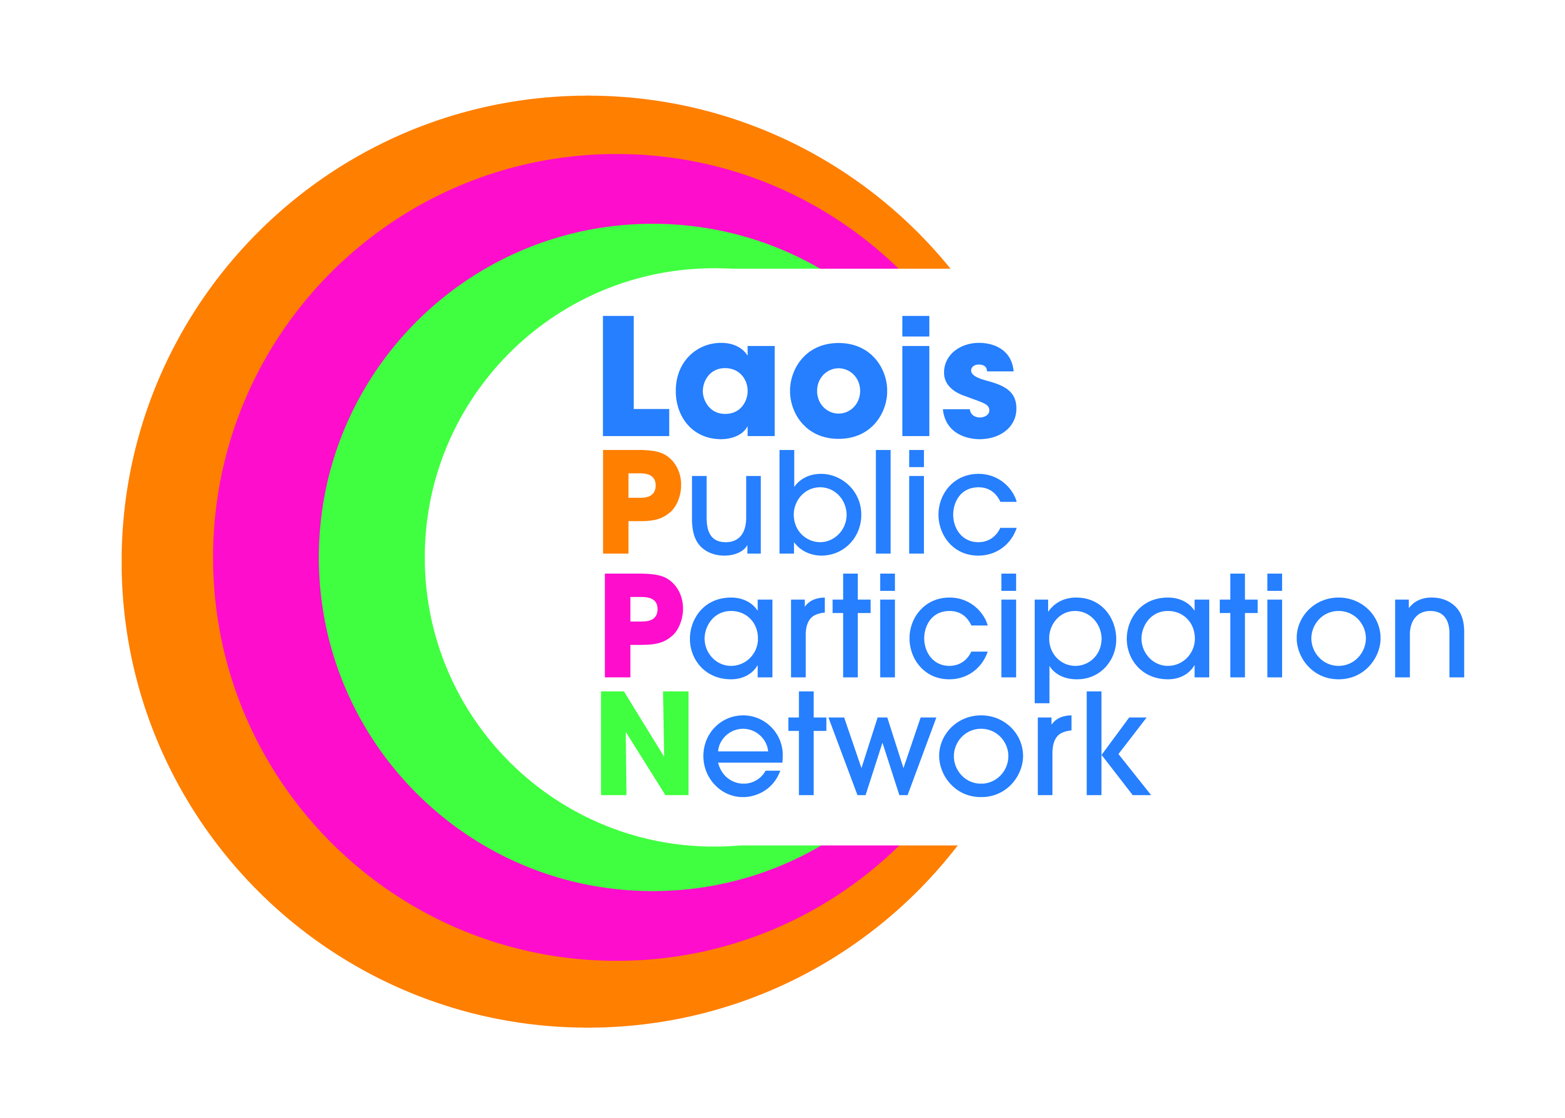
Laois Public Participation Network
Minutes of Meeting of PPN Secretariat
Monday, 15th May 2019, at 5:00pm
The Midlands Park Hotel, Portlaoise, Co. Laois.

Present: Mr. Mick Dowling - Chair
Mr. PJ Campbell
Mr. Michael Cobbe
Mr. Donal O’Shea
Mr. Paddy Buggy
Mr. Robbie Quinn

Apologies: Mr. Brian Maher
Mr. Bolaji Adeyanju
Mr. John Bonham

In Attendance: Ms. Suzanne O’Connor, PPN Coordinator.

The minutes of the meeting held on 15thApril, 2019 were proposed by Michael Cobbe, seconded by Paddy Buggy, confirmed and signed.

Disability Report Launch: The launch will take place on Tuesday 21st May @ 7:30pm. The report is a direct result of the views of attendees on the night and some goals would be considered as long term goals.

2nd Plenary: Work on two items on the “To Do” list i.e. Plastic and Insurance with two speakers to give a presentation on both at plenary. Elections will also take place with expression of interest on all vacant seats to be sent to member organisations early Sept. It was agreed that the event will take place in early October.

Age Friendly: The age friendly co-ordinator made contact with Laois PPN with a view that Laois PPN fill a seat on the alliance, subject to consent from Laois Age Friendly committee and Laois PPN. With PPN elections due in October the secretariat agreed that they would review this again at a later date. Need to know more in relation to what is required from Laois PPN in filling the seat.

Major Emergency Management Committee: As a result of an e-mail received from Padraic Keely (Assistant Chief Fire Officer, Laois County Fire & Rescue Service) in relation to adding Laois PPN to the distribution list and the possibility of joining the Committee the secretariat overwhelming decided that this was a great idea, ensuring that Laois PPN would have the ability to keep member organisations informed of any severe weather warning etc.
Linkage Groups: This was discussed at length and agreed that there needs to be correlation between groups. It was decided to put options into an e-mail and send to the secretariat and take a return vote via email. This exercise is to be completed before the next monthly meeting.
Paddy Buggy was elected to chair the next three monthly secretariat meetings.
Any Other Business:
- PJ Campbell requested that the cost of insurance for community groups should be added to our “To Do” list. This is something that Laois PPN could work on. Proposed: Michael Cobbe, seconded: Robbie Quinn. It was suggested that a survey be developed and sent to all member organisations to get feedback on insurance costs.
- Midlands ISL requested approval for Laois PPN to be used as a reference on funding/grant application. The secretariat approved this request.
- Suzanne informed the secretariat of Laois Africa Day. The secretariat requested that this information be e-mailed.

This concluded the business of the meeting.

Signed:
Chairperson

Date: / /

