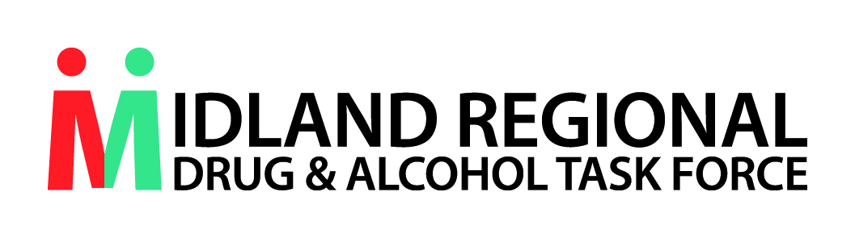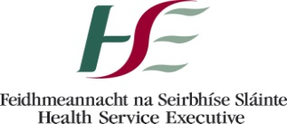
Training Booking Form 2019
Name of Training | Drug related Intimidation Reporting Programme
Date of Training | 12.9.2019
Applicant Details
Name:
Position Held:
Phone No:
Email:
Organisation/Group Details
Name of Organisation/Group:
Organisation/Group details:
Profile of your target group:

Address:
Training Application
What do you hope to learn from this training

Approval by Line Manager to attend training | Signature________________________________________________  Date ________________________________________________
Please return booking form to:
The MRDATF office email: Teresa.Murphy8@hse.ie or post to Teresa Murphy, MRDATF, Health Centre, Coosan Road, Athlone, Co Westmeath. You will be contacted by email to confirm if you have secured a place on the training. Please ensure all sections of the booking form are completed.

