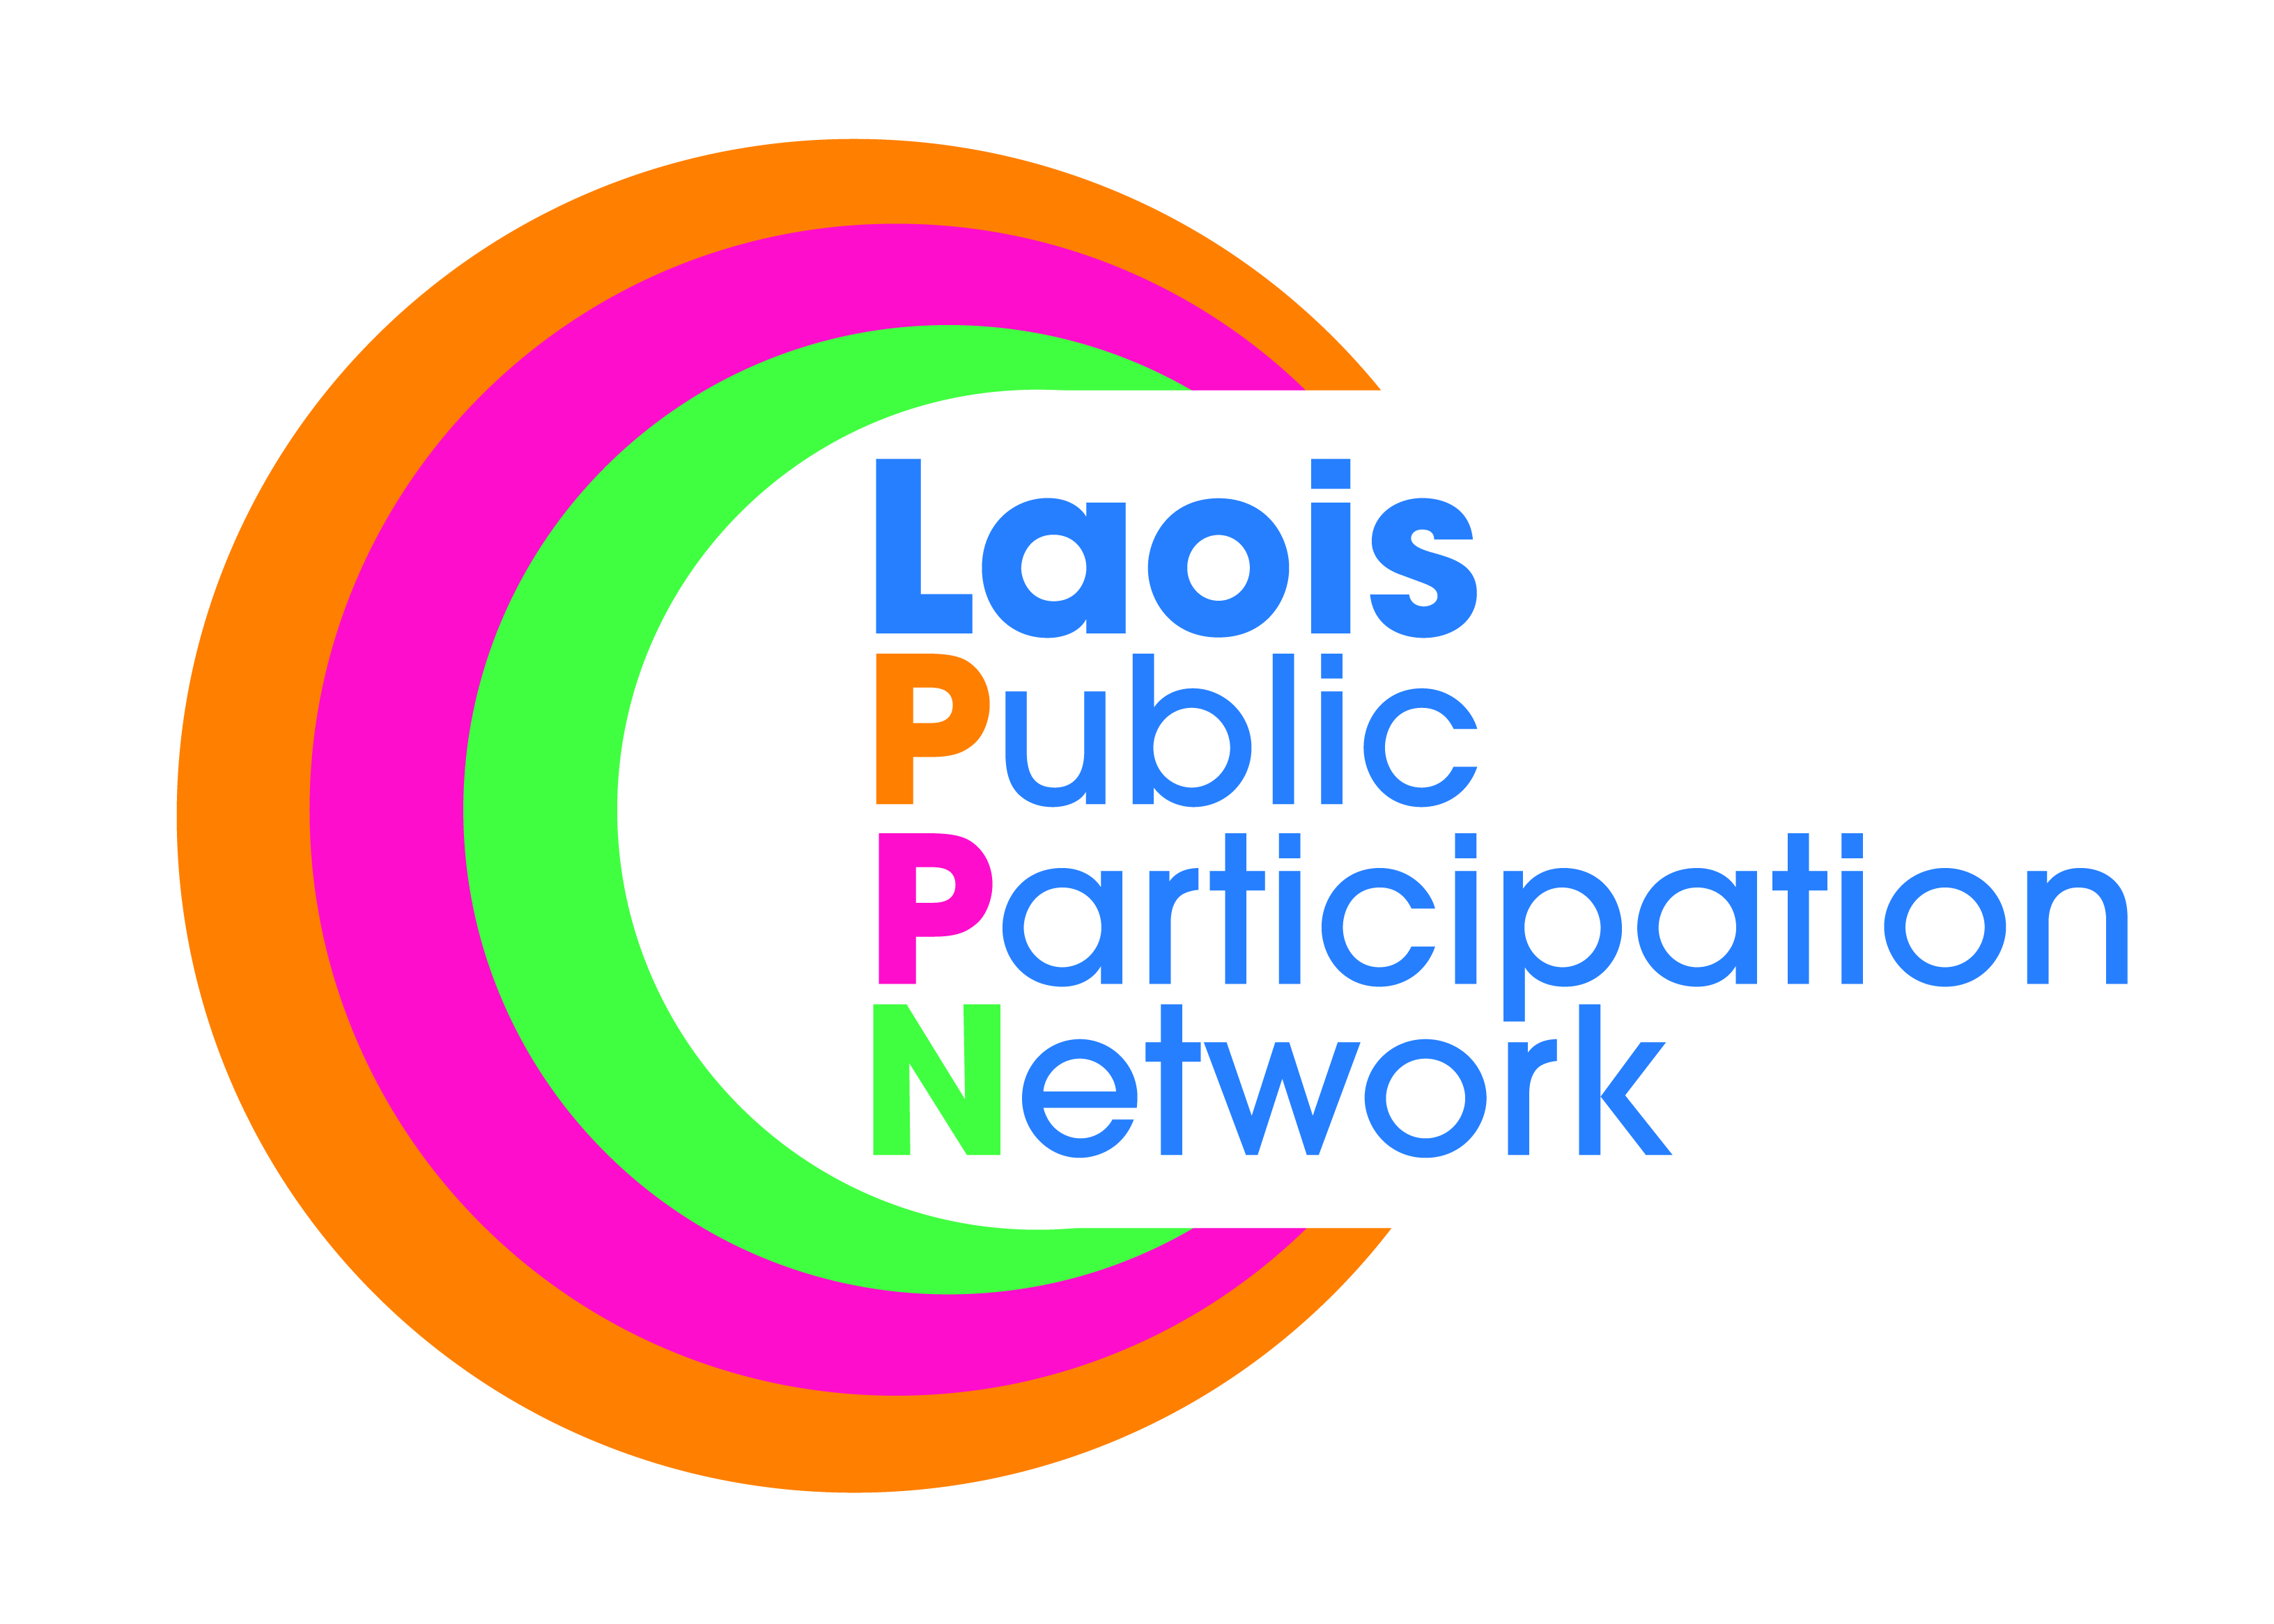
Nomination Paper for Laois Public Participation Network
Area Representative (to PPN Secretariat)
GRAIGUECULLEN/PORTARLINGTON MD
To the Returning Officer:
- I nominate the person named under as a candidate for election to the above-mentioned committee as the Area Representative for the GRAIGUECULLEN/PORTARLINGTON Municipal District.
- For a valid nomination we seek details of a nominated candidate and nominating group. Please only supply these details if you have permission to do so. Please tick the box to confirm you have permission to provide such details.
- I confirm upon signature that I have read and understood the notes (overleaf*) on this nomination paper and declare that I believe this person to be eligible for this position.
Please use BLOCK LETTERS
Surname of Candidate Other Names

Address Occupation (if any)

Signature of Candidate

Name of Nominating Group/Organisation PPN Ref. No.

Name of Person completing this Nomination Form (Proposer)
Please Print Signature
Please attach passport size photograph of candidate for inclusion on ballot paper
Date
Address of Proposer

Daytime Tel. No

NOTES:
- The completion of this form nominates a candidate to stand election for:
Area Representative in the GRAIGUECULEN/PORTARLINGTON MD Area to the PPN Secretariat.
- The PPN Secretariat is the hub of the PPN Structure and the mechanism through which all operations will take place. 12 representatives will be responsible for the operation of the PPN, i.e., convening plenary meetings at county and municipal district levels, providing networking opportunities between local and/or like minded groupings and ensuring that a two-way feedback process is maintained between community groups and the local authority.
- The person to be nominated must be a member of a group/organisation that is registered with Laois Public Participation Network in the correct municipal district.
- The group making the nomination must be registered with Laois Public Participation Network and must be a member of the PPN in the GRAIGUECULLEN/PORTARLINGTON Municipal District.
- The group nominating MUST be a member of the respective municipal district,

- Clearly mark the envelope “PPN ELECTION NOMINATION” and return to;

Laois Public Participation Network
JLF Avenue,
Lyster Square,
Portlaoise,
Co. Laois.

- A receipt for your nomination will be issued to the nominee and a valid declaration will issue subsequently, if applicable.
- Deadline for receipt of nominations is 4.00pm, Friday 11th October 2019.

