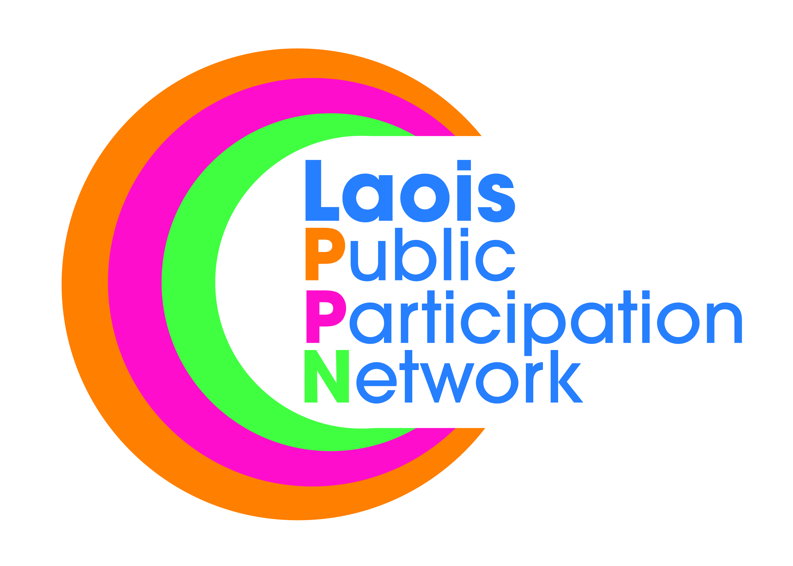
Nomination Paper for Laois Public Participation Network
Environment Representative
on the Strategic Policy Committee/s of Laois Co Co.
- Housing Regeneration & Planning SPC
- Climate Action & Community SPC
- Transport, Environment & Emergency Services SPC
(Candidates can be nominated to run for election to one or all of the above SPCs. Please tick one or all of above SPC’s that you are nomination the below Candidate)
To the Returning Officer:
- I nominate the person named under as a candidate for election to the above-mentioned committee/committees as the Environment representative.
- For a valid nomination we seek details of a nominated candidate and nominating group. Please only supply these details if you have permission to do so. Please tick the box to confirm you have permission to provide such details.
- I confirm upon signature that I have read and understood the notes (overleaf*) on this nomination paper and declare that I believe this person to be eligible for this position.
Please use BLOCK LETTERS
Surname of Candidate Other Names

Address Occupation (if any)

Signature of Candidate

Name of Nominating Group/Organisation PPN Ref. No.

Name of Person completing this Nomination Form (Proposer)
Please Print Signature
Please attach passport size photograph of candidate for inclusion on ballot paper
Date
Address of Proposer

Daytime Tel. No

NOTES:
- The completion of this form nominates a candidate to stand election as the:
Environment Representative on the:
- Housing Regeneration & Planning SPC
- Climate Action & Community SPC
- Transport, Environment & Emergency Services SPC.
- Strategic Policy Committees advise and assist the Council in its work under a number of headings. The S.P.C. system is intended to give Councillors and relevant sectoral interests an opportunity for full involvement in the policy making process from the early stages.

- The Housing Regeneration & Planning SPC covers the policy areas of Housing including Social Housing, Housing Regeneration, Traveller Accommodation, Forward Planning & Heritage.

- The Climate Action & Community SPC covers the policy areas of Climate Action, Community Development, Libraries, Culture & Art and Sports and Recreation.

- The Transportation, Environment & Emergency Services SPC covers the policy areas Roads, Transport and Parking, Flood Relief, Water & Environmental Protection, Emergency Management and Energy Efficiency
- The person to be nominated must be a member of a group/organisation that is registered with Laois Public Participation Network in the correct pillar grouping.
- The group nominating MUST be a member of the respective pillar grouping, i.e., to be nominated as an Environment rep, it must be a Environment group nominating you, and similarly for Community/Voluntary and Social Inclusion reps.
- Clearly mark the envelope “PPN ELECTION NOMINATION” and return to:
Suzanne O’Connor,
Laois Public Participation Network,
JFL Avenue,
Lyster Square,
Portlaoise,
Co. Laois.

oe E-mail: ppn@laoiscoco.ie

- A receipt for your nomination will be issued to the nominee and a valid declaration will issue subsequently, if applicable.
- Deadline for receipt of nominations is 4.00pm, Friday, 11th October, 2019.

