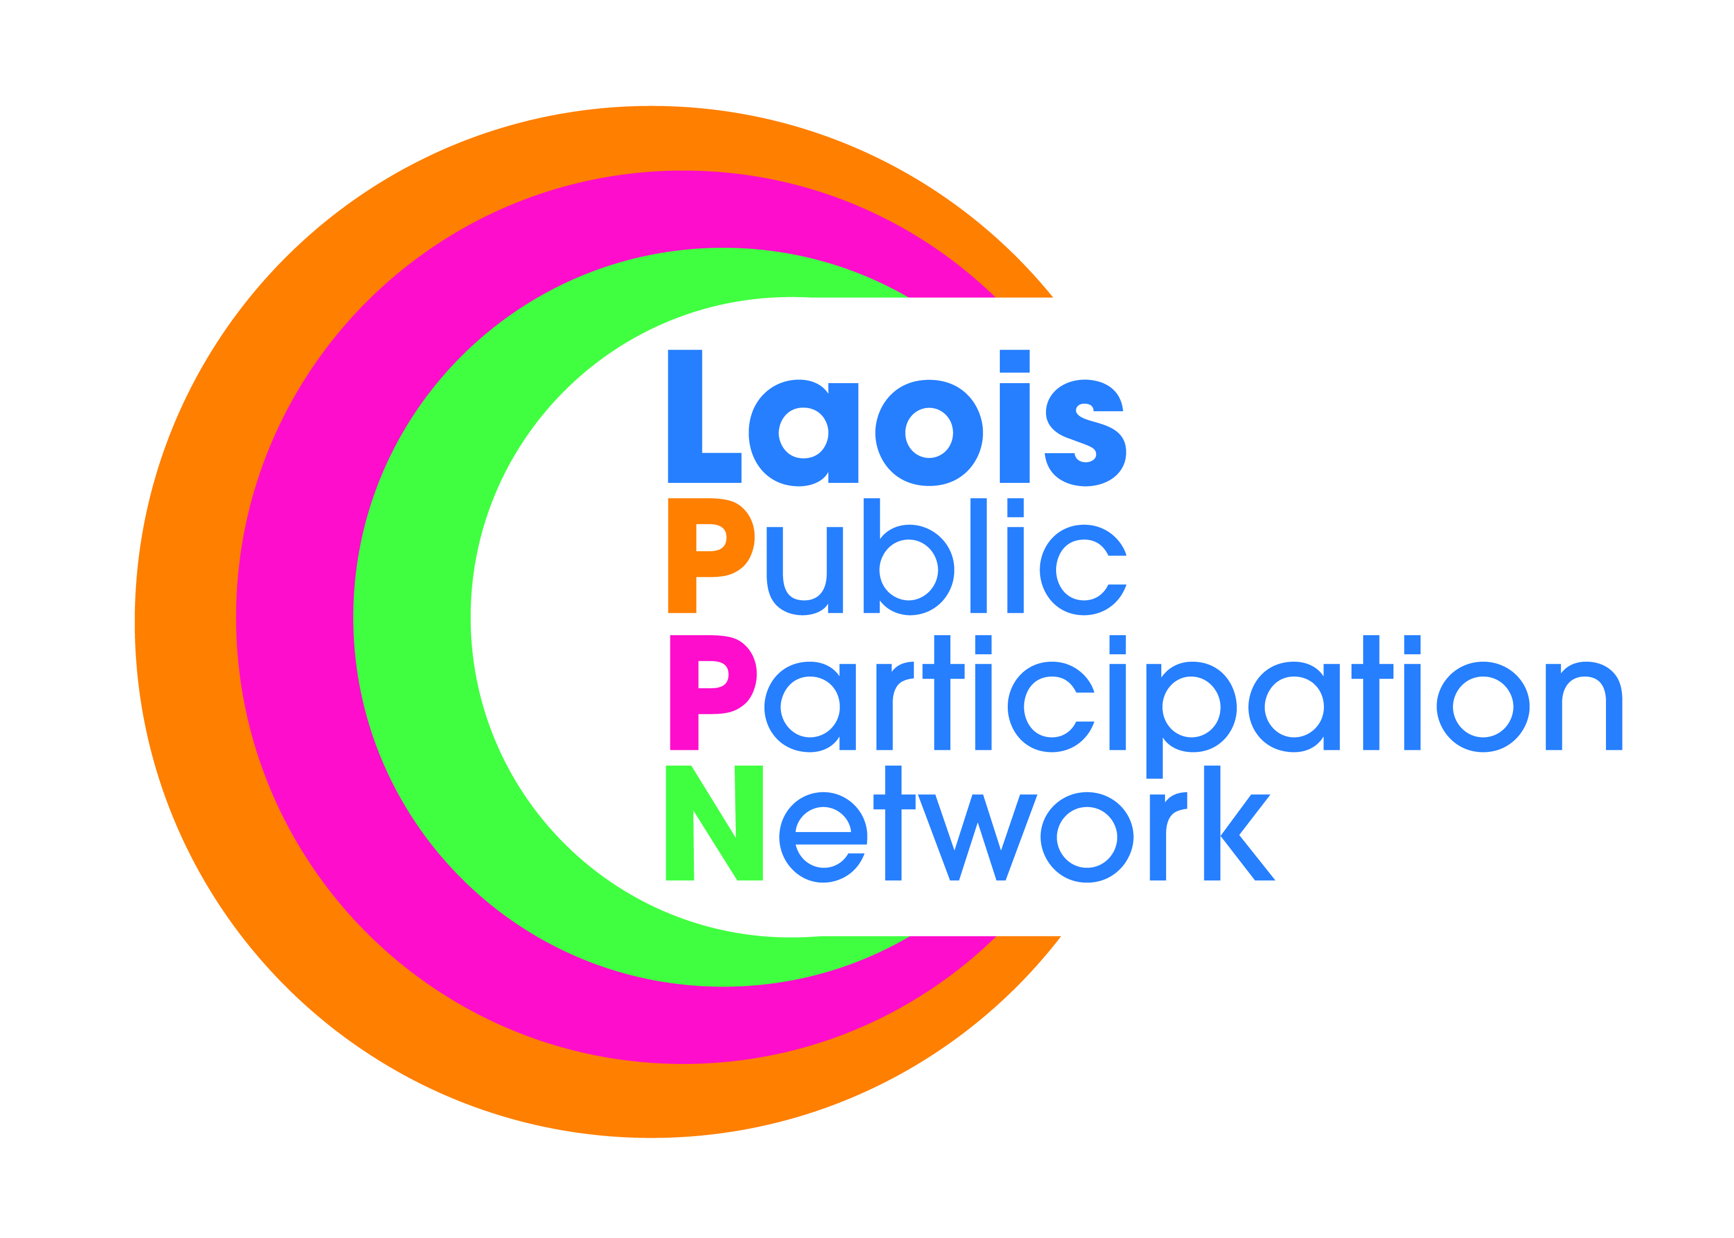
Nomination Paper for Laois Public Participation Network
Social Inclusion Representative
on the Strategic Policy Committee/s of Laois Co Co.
- Climate Action & Community SPC
- Housing Regeneration & Planning SPC
(Candidates can be nominated to run for election to one or all of the above SPCs. Please tick one or all of above SPC’s that you are nomination the below Candidate)
To the Returning Officer:
- I nominate the person named under as a candidate for election to the above-mentioned committee/committees as the Social Inclusion representative.
- For a valid nomination we seek details of a nominated candidate and nominating group. Please only supply these details if you have permission to do so. Please tick the box to confirm you have permission to provide such details.
- I confirm upon signature that I have read and understood the notes (overleaf*) on this nomination paper and declare that I believe this person to be eligible for this position.
Please use BLOCK LETTERS
Surname of Candidate Other Names

Address Occupation (if any)

Signature of Candidate

Name of Nominating Group/Organisation PPN Ref. No.

Name of Person completing this Nomination Form (Proposer)
Please Print Signature
Please attach passport size photograph of candidate for inclusion on ballot paper
Date
Address of Proposer

Daytime Tel. No

NOTES:
- The completion of this form nominates a candidate to stand election as the:
Social Inclusion Representative on the:

- Climate Action & Community SPC
- Housing Regeneration & Planning SPC
- Strategic Policy Committees advise and assist the Council in its work under a number of headings. The S.P.C. system is intended to give Councillors and relevant sectoral interests an opportunity for full involvement in the policy making process from the early stages.

- The Climate Action & Community SPC covers the policy areas of Climate Action, Community Development, Libraries, Culture & Art and Sports and Recreation.

- The Housing Regeneration & Planning SPC covers the policy areas of Housing including Social Housing, Housing Regeneration, Traveller Accommodation, Forward Planning & Heritage.

- The person to be nominated must be a member of a group/organisation that is registered with Laois Public Participation Network in the correct pillar grouping.
- The group nominating MUST be a member of the respective pillar grouping, i.e., to be nominated as a Social Inclusion rep, it must be a Social Inclusion group nominating you, and similarly for Community/Voluntary and Environmental reps.
- Clearly mark the envelope “PPN ELECTION NOMINATION” and return to:
Suzanne O’Connor,
Laois Public Participation Network,
JFL Avenue,
Lyster Square,
Portlaoise,
Co. Laois.

or E-mail: ppn@laoiscoco.ie

- A receipt for your nomination will be issued to the nominee and a valid declaration will issue subsequently, if applicable.
- Deadline for receipt of nominations is 4.00pm, Friday,11th October, 2019.

