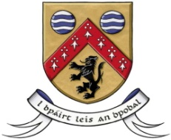

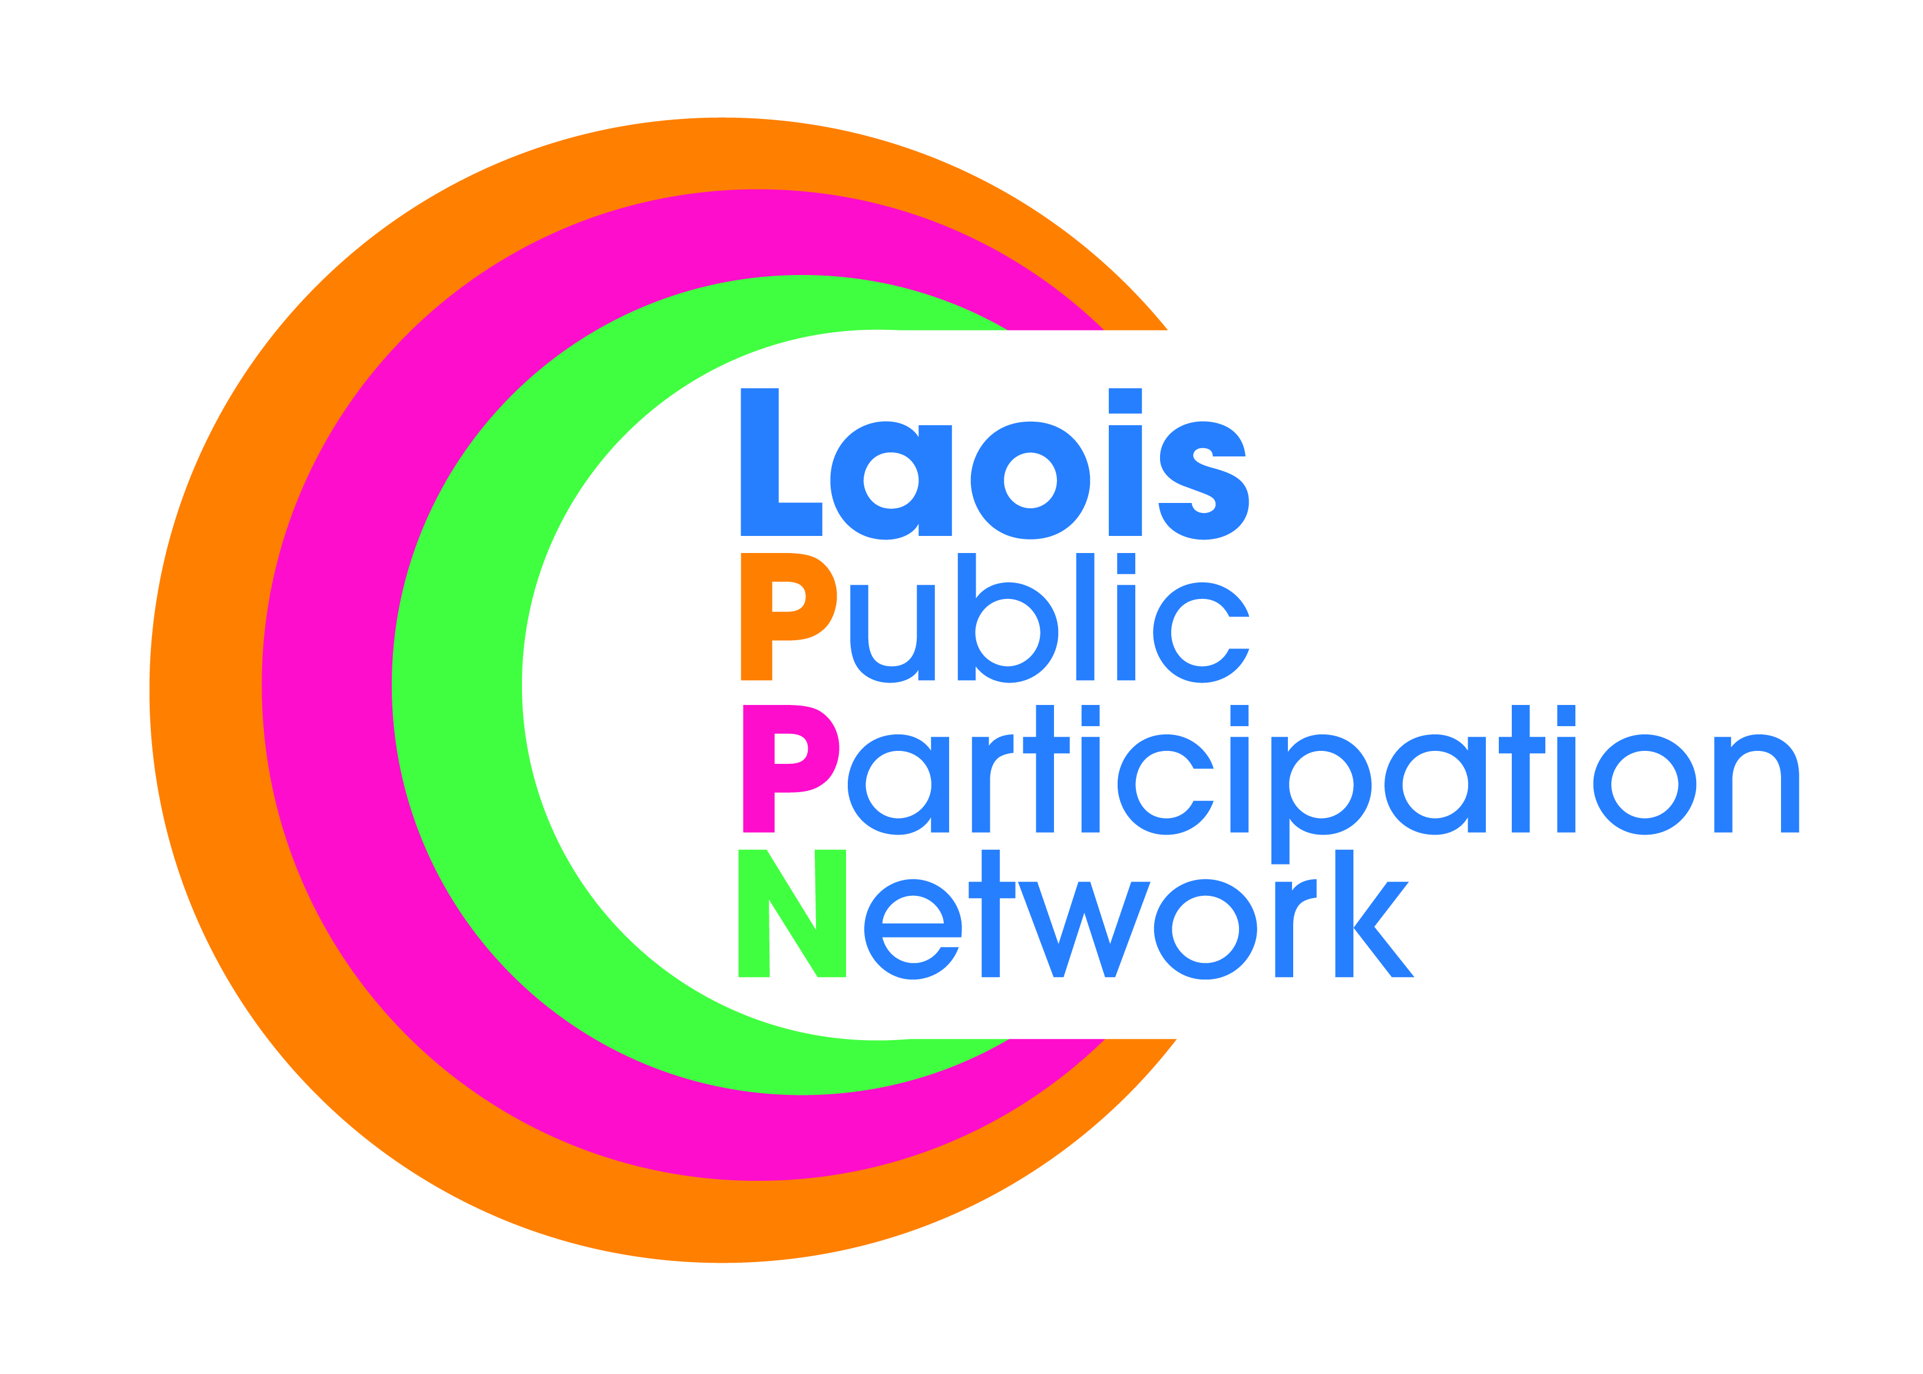



**Laois County Council**

***In partnership with***

***Laois Public Participation Network***

**Community & Voluntary Awards 2022**

**Nomination Form**

***This form should be used to nominate a Group/Club/Organisation Only.  
Groups/Clubs/Organisations can nominate themselves.***

**N.B! Before completing this form, please read the accompanying terms & conditions and judging criteria**

**TERMS & CONDITIONS:**

1. To ensure judging is fair and impartial, Judges will be selected from outside of County Laois.
2. The group/club/organisation must be well established.
3. The group/club/organisation must be registered with Laois Public Participation Network.
4. Please note that the nominator can be a member of the nominated group. Alternatively, it is not necessary that the person/group making the nomination is associated with, or a member of, the nominated group.
5. The group should not be in receipt of regular State funding, e.g., regular grant aid. Should the group have received a once-off grant for a particular item/project, this should be disclosed and will be judged accordingly.
6. The nominated group must have set out what they are about, highlighting their current/recent activities and achievements and the impact that all of their activities have on the local and wider community including, if appropriate, their level of participation locally and their level of volunteerism.
7. The nominated group must have set out what their plans are for the future, based on their commitment to making a difference in the community.
8. Prior to completing and submitting the nomination, please ensure you have the Consent of the group being nominated to furnish this application and to share their personal data with Laois Co Co, for this purpose.
9. Please submit photos and/or accompanying documentation, as part of the nominated application. Please email photos or post copies only of photos, certificates, etc, as originals may not be returned.
10. A minimum of two digital photographs must accompany the application form. Photographs should be of good quality and may be used for publication.
11. Photographs may be used by Laois Co Co for advertisement and publications about the Awards Ceremony, for inclusion with Posts on Social Media sites, be used for the ceremony production and included in Council publications, to include but not limited to the Annual Report, Council Newsletter and Management Reports.
12. Please ensure that you have the Consent of the nominated group, whose photos are to be used in this manner. If submitting photos of individuals, please ensure that you have the Consent of said persons, prior to submission.
13. By entering this process, you give Consent to the submitted photos being used in this manner.
14. Nominations will be shortlisted by an independent Committee. Nominees will be notified in writing.
15. Laois County Council reserve the right to contact the nominated group, to confirm all aforementioned Consent was forthcoming.
16. Groups can only be nominated in one category.

**JUDGING CRITERIA**

*Groups will be judged by the Adjudication Panel based on the following criteria:*

* Contribution of the group to the community ;
* How representative the group is of the community;
* Level of voluntary involvement and participation;
* How well a group, service and/or activities are planned and delivered, and the use of innovative approaches;
* Positive impact of the work of the group on the local and wider community;
* Positive impact the work has had on the target category, i.e., arts, community services & support, sports & recreation, etc;
* Use of inclusive working methods, e.g., reaching out to ensure that those who most need to actually get involved/benefit from inclusion;
* Future benefits to the community

**Completed application should be sent by email to** [**awards@laoiscoco.ie**](mailto:awards@laoiscoco.ie) **or posted to**

**Community Awards Section, Laois County Council, Áras an Chontae, Portlaoise, Co Laois and marked:**

**“Community & Voluntary Awards 2022 Nomination”.**

**Closing Date is 4pm on Friday, 19th August, 2022**

**For further assistance and queries, please contact (057) 86 64078 or email** [**awards@laoiscoco.ie**](mailto:awards@laoiscoco.ie)

***Under which Category do you wish to nominate a Group/Club/Organisation:***

**Application Form**

**Please tick ONE only**

|  |  |
| --- | --- |
|  | Arts, Culture &Heritage  This award recognises Groups/Organisations who enhance their local areas, by conserving, protecting and promoting the Arts, Culture and Heritage of their local community through collective creative activities. Examples include: Drama, Music, Literature, Arts, Festivals, Conservation, and Heritage. |
|  | Sports Award  This award focuses on groups or schools, who have focused on physical health, increasing the number of people participating in the sport, particularly those with a low participation rate. |
|  | Best Kept Residential Area |
|  | This award recognises the hard work and dedication shown in residential areas throughout Laois, recognises the great pride people have in their own communities, recognise the value of our biodiversity and continued to put in a huge effort, on behalf of the places where they live. |
|  | Social Inclusion  This award recognises Groups/Organisations that actively work in a supportive role in their communities and whose aim is to minimise social exclusion and/or help to improve the quality of life for socially excluded groups. Examples include; Working with the elderly, People with Disabilities, Ethnic Minority, Travelling Community, Young people in transition, LGBTI+ and the Homeless.  Health and Well Being |
|  | This award recognises community health and wellbeing initiatives i.e mental health, sexual health, awareness raising & promotion around medical conditions, disorders and disabilities, including opportunities for social connections, increased meaningful daily activities, developing confidence and providing a sense of purpose & positive self-worth for citizens in the community. |

***I wish to nominate the following Group/Club/Organisation for a Community & Voluntary Award:***

|  |  |
| --- | --- |
| **Name of Group/Club/ Organisation/ Junior Volunteer** |  |
| **Address** |  |
| **Contact Name** |  |
| **Phone No.  (daytime contact)** | C:\Documents and Settings\gireland\Local Settings\Temporary Internet Files\Content.IE5\YHXURAT4\MC900340830[1].wmf |
| **Email address for contact** | C:\Documents and Settings\gireland\Local Settings\Temporary Internet Files\Content.IE5\6F7AXZN2\MC900442124[1].png |

**Is the Group/Organisation a member of Laois PPN? Yes NO**

1. **No. of Voluntary workers** **No. of Paid Workers**
2. **What year was your Group/Club/Organisation founded?**
3. **How is the Group funded?**_______________________________________________________________

___________________________________________________________________________________

***NOMINATOR: (the person or group making the nomination – please ensure you read the terms & conditions regarding this section!)***

|  |  |
| --- | --- |
| **Your Name  *(either an individual or a group)*** |  |
| **Your Address** |  |
| **Phone No. *(daytime contact)*** | C:\Documents and Settings\gireland\Local Settings\Temporary Internet Files\Content.IE5\YHXURAT4\MC900340830[1].wmf |
| **Email address for contact** | C:\Documents and Settings\gireland\Local Settings\Temporary Internet Files\Content.IE5\6F7AXZN2\MC900442124[1].png |

**State the reasons why the Group/Club/Organisation deserves the Award?**

1. ____________________________________________________________________________________
2. ____________________________________________________________________________________
3. ____________________________________________________________________________________
4. ____________________________________________________________________________________
5. ____________________________________________________________________________________
6. ____________________________________________________________________________________

**Please highlight the current/recent activities and achievements of the nominated Group/Club/ Organisation?  
(Use photos and/or separate pages to illustrate these if you prefer)**

__________________________________________________________________________________________________________________________________________________________________________________________________________________________________________________________________________________________________________________________________________________________________________________________________________________________________________________________________

**How does the Group/Club/ Organisation benefit the community?**

__________________________________________________________________________________________________________________________________________________________________________________________________________________________________________________________________________________________________________________________________________________________________________________________________________________________________________________________________

**What are the future plans of the Group/Club/Organisation?**

________________________________________________________________________________________________________________________________________________________________________________________________________________________________________________________________________________________________________________________________________________________________________

______________________________________________________________________________________________________________________________________________________________________________________________________________________________________________________________________________

* By completing and submitting this form, I hereby confirm that I have read and understand the terms and conditions, judging criteria and the data protection requirements.
* In addition to the aforementioned, I hereby confirm that I have the Consent of the nominated group to share their personal data, relevant for the administration of Laois Community and Voluntary Awards, 2022.

**SIGNED: DATE:**

**Data Protection**

In accordance with the General Data Protection Regulations 2018, the definition of personal data is  – ‘personal data’ means any information relating to an identified or identifiable natural person (‘data subject’); an identifiable natural person is one who can be identified, directly or indirectly, in particular by reference to an identifier such as a name, an identification number, location data, an online identifier or to one or more factors specific to the physical, physiological, genetic, mental, economic, cultural or social identity of that natural person.

Laois County Council creates, collects and processes a significant amount of personal data in various multiple formats on a daily basis. Laois County Council’s commitment is that the personal data you may be required to supply to us is:

* Obtained lawfully, fairly and in a transparent manner
* Obtained for only the purposes of the Laois Community & Voluntary Awards 2022
* Adequate, relevant and limited to what is necessary for purpose for which it was obtained.  Data will be used for administration of Laois Community and Voluntary Awards 2022 as outlined above and for financial purposes.  Necessary information will be shared with the Accounts Payable Section of Laois County Council for the purposes of grant payments.  Data will be used for audit purposes.
* Data will be recorded, stored accurately and securely and where necessary kept up to date.
* Data will be kept securely in the Community Development Section of Laois County Council for a period of 6 years after completion of the project, after such time it will be destroyed.
* Legal basis – Local Government reform Act 2014

Your Data Protection Rights

You have the right to request access to personal data held about you, obtain confirmation as to whether data concerning you exists, be informed of the content and source of data and check its accuracy. In addition, if the data held by us is found to be inaccurate you have the right to change, remove, block, or object to the use of, personal data held by Laois County Council. In certain circumstances blocking access to data may delay or remove access to a service where the data is required by law or for essential purposes related to delivery of a service to you. Please note that to help protect your privacy; we take steps to verify your identity before granting access to personal data.

To exercise these rights, you should take the following steps:

Forward your completed request to the Data Protection Officer at the following address:

Data Protection Officer,

Laois County Council,

Áras an Chontae,

Portlaoise,

Co. Laois.

R32EHP9

Or by email to: [dataprotection@laoiscoco.ie](mailto:Dataprotection@laoiscoco.ie)